INFORMATION SHEET
Special Account for Business Recovery and Resilience:
Assistance to SMEs and Critical Sectors

Implementing Country |  | Malaysia
Plan | Description/Explanation
1. | Type of Assistance | End-users Proof of Concept on Artificial Intelligence (AI) based machine vision system for Electrical & Electronics to train and reskill workforce, especially those affected by pandemic, to stay relevant in the industry
2. | Description | Whilst Industry 4.0 adoption is deemed crucial for  business survival and further growth in innovation led value creation, we still do not see an easy path  for SMEs to step up to embrace the opportunity,  either as the adopter of the trend or a creator of the value. Among the main challenges that faced by SMEs are: costly technology adoption and capital investment;  difficulties to get knowledge encountered by SMEs;  Expensive equipment and high maintenance costs; and most importantly, no local solutions available or they’re not connected to the latest skills and technology to meet optimum level of their factory production.  This is not an ordinary training process, but one that helps end-users to solve their problems at hand and hoping that they bring home the solutions and see it implemented in their environment. SMEs can do greater things if they are provided with the right tools and assistance.  Machine vision systems can recognize well-defined  patterns and determine if they match those stored  in the database in ensuring quality assurance and inspection.  They’re also able to detect the presence or absence  of objects, such as a label on a bottle, screws in  an assembly, chocolates in a box, or defects.  Among the benefits including:-  - Efficiency (better use of time speeds up processes)  - Productivity (identify and eliminate process errors)  - Safety (people exposed to less hazardous environment)  - Innovation (new product and service opportunities or new markets)  The Artificial Intelligence (AI) based machine vision system starter kit consists of NVIDIA Jetson Nano 2GB Developer Kit, Jetson Nano Enclosure, USB Web Camera, Ethernet Cable, Power Supply (USB Type C) and some colored bricks.  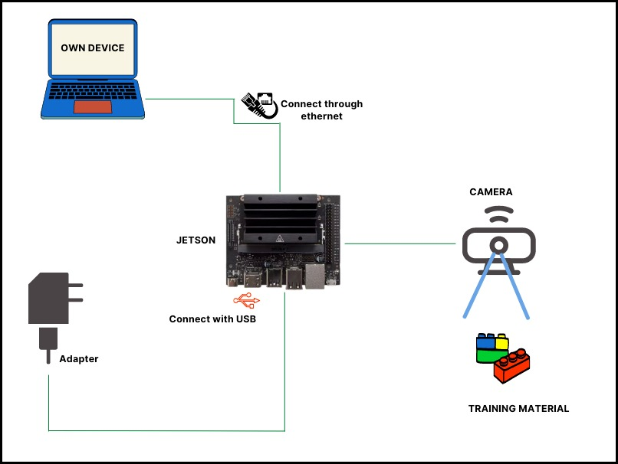  In the five half-day training program, participants are taught images capturing techniques, images  detection and labeling systems, machine learning and model algorithms. Participants are also taught  Node-RED programming and to use the Dashboard module to visualize the results of their inferencing. This hands-on programme aims to educate and empower the talents within E&E industry by bringing industry players, ecosystem providers and key government agencies together to coach, prepare and enable 20-25 companies to carry out a proof-of-concept (POC) project each at their company using AI-based machine vision system. Through this programme and empowerment aimed at transferring the required competencies will impact the participating company’s capacity building and productivity improvement.
3. | Objectives | To support, coach, prepare and enable 40~50 technical participants to carry out AI-based machine vision project within their company with complete AI starter-kit
4. | Activity(es) | - To train 40~50 pax to carry out a project at their company. (20-25 companies based on max 2 from each company).  - This training will be conducted virtually for 5 half day training with:  - 2 half-days participants will be guided on Introduction of AI Solution Overview and Case Studies and unboxing Starter Kit  - 3 half-days hands-on session on devices setting up, software configuration with inference and visualization background process  - Participants are also taught Node-RED programming and to use the Dashboard module to integrate to the python backend with dashboard setup guidance and customization  - Technology principals/partner will guide participants in developing their POC up till presentation by companies
5. | Schedules | May – July 2022
  Activity | Duration
  - Promotional/marketing Activities | May
  - Training | Jun
  - Proof of Concept | July
6. | Main Beneficiary(es) | SME companies from  - Electrical & Electronics  - Other manufacturing-related sectors
7. | Stakeholders Involved | - Ministry of International Trade & Industry  - Malaysia Productivity Corporation  - Productivity Nexus  - Technology partners  - Industry Associations
8. | Budget Breakdown | USD14,500.00
8. | Budget Breakdown | Item | Estimated cost (USD)
8. | Budget Breakdown | Development of training module | 1,000
8. | Budget Breakdown | AI starter kit (25 sets X USD243) | 6,075
8. | Budget Breakdown | Training fees of 5 half-day + 1 day coaching (USD297/company) | 7,425
8. | Budget Breakdown | Technical support, virtual platform and logistics cost | foc
8. | Budget Breakdown | Total | 14,500
9. | Expected Outcome | - Productivity Improvement at firm level:- Results after the implementation, ROI/Cost Savings/Quantifiable output, e.g. Reduced machine idle and downtime  - Increased the Overall Equipment Efficiency (OEE)  - Reduced human errors  - Reduced no. of headcounts  - Cost saving on manual paper recorder  - Real time/live monitoring system  - Company-wide proliferation of AI-based machine vision to enhance competitiveness
10. | Other Information | Productivity Through Digitalisation: EEPN End-Users Plugfest Projects Compilation  https://wayup.my/wp-content/uploads/2021/03/EEPN-Plugfest-Booklet-E-Book-2-9.pdf

