Administrative Circular

APEC MALAYSIA CONFERENCE 2022 (AMC2022)




25 - 26 January 2022
Malacca

Table of Contents

Agenda 3
Venue and Dates 7
Participants 8
Accommodation 8
Dress Code 8
Parking 9
Amenities 9
Weather Forecast 10
Etiquette 11
Emergency Evacuation 12
Disclaimer 12
Organising Committee Details 12

Agenda

Day 1 (Tuesday, 25 January 2022)

Time | Agenda | Venue
8.00 AM –  9.00 AM | Registration and Breakfast | Makan Kitchen, Level 12
9.00 AM –  9.30 AM | Welcoming Remarks  Ms. Vimala Murugan  APEC Senior Official for Malaysia (SOM Malaysia)  Senior Director  APEC Division  Ministry of International Trade and Industry | Ballroom B,  Level 13
SESSION A: APEC 2022
9.30 AM – 11.00 AM | Session 1: APEC 2021 Outcomes and Aotearoa Plan of Action  APEC 2021 SOM Chair’s Office /  The High Commission of New Zealand | Ballroom B,  Level 13
11.00 AM – 11.15 AM | Break | Foyer of  Ballroom B
11.15 AM – 12.30 PM | Session 2: Theme and Priorities for APEC 2022 and the Bio-Circular-Green (BCG) Model  APEC 2022 SOM Chair’s Office /  The Embassy of Thailand | Ballroom B,  Level 13
12.30 PM – 2.30 PM | Lunch | Makan Kitchen, Level 12
2.30 PM –  3.15 PM | Session 3: Updates from APEC Committees  Representatives from CTI, SCE and EC Units  APEC Division  Ministry of International Trade and Industry | Ballroom B,  Level 13
3.15 PM –  3.30 PM | Break | Foyer of  Ballroom B
SESSION B: DOMESTIC AND INTERNATIONAL POLICIES RELEVANT TO APEC 2022
3.30 PM –  4.15 PM | Session 4: Twelfth Malaysia Plan (12MP)  Economic Planning Unit,  Prime Minister’s Department | Ballroom B,  Level 13
4.15 PM –  5.00 PM | Session 5: Updates on the Multilateral Trading System (MTS) and the World Trade Organisation (WTO)  Multilateral Trade Policy and Negotiations Division  Ministry of International Trade and Industry | Ballroom B,  Level 13
8.30 PM – 10.30 PM | AMC2022 Retreat | Ballroom A,  Level 13
End of Day 1

Note: Please note that participants’ breakfast and lunch will be provided throughout the 2-day Conference.

Day 2 (Wednesday, 26 January 2022)

Time | Agenda | Venue
8.00 AM –  9.00 AM | Registration and Breakfast | Makan Kitchen, Level 12
9.00 AM –  9.45 AM | Session 6: Updates on the 2021 United Nations Climate Change Conference (COP26) and Paris Agreement  Ministry of Environment and Water (KASA) | Ballroom B,  Level 13
9.45 AM –  10.30 AM | Session 7: Updates on the Sustainable Development Goal (SDG) 2030  Economic Planning Unit,  Prime Minister’s Department | Ballroom B,  Level 13
10.30 AM – 10.45 AM | Break | Foyer of  Ballroom B
SESSION C: APEC FUNDING AND CLINIC SESSION
10.45 AM – 12.30 PM | Session 8: APEC Funding Opportunities and Concept Notes  Project Management Unit (PMU),  APEC Secretariat | Ballroom B,  Level 13
12.30 PM –  2.30 PM | Lunch | Makan Kitchen, Level 12
2.30 PM –  4.30 PM | Session 9: Concept Notes Clinic  (Breakout Sessions with Respective Committees) | Ballroom B,  Level 13
4.30 PM –  5.00 PM | Closing Remarks and Appreciation Ceremony for Malaysia’s Projects for 2020/2021  Mr. Hairil Yahri Yaacob  Deputy Secretary General (Trade)  Ministry of International Trade and Industry | Ballroom B,  Level 13
End of Day 2

Note: Please note that participants’ breakfast and lunch will be provided throughout the 2-day Conference.

Venue and Dates
The APEC Malaysia Conference 2022 (AMC2022) will be held from 25 to 26 January 2022. The venue is as follows:

DoubleTree by Hilton Melaka  Jalan Melaka Raya 23  Hatten City  75000 Melaka  Contact No: 06-222 3333  Website: https://www.hilton.com/en/hotels/mkzmmdi-doubletree-melaka/ | 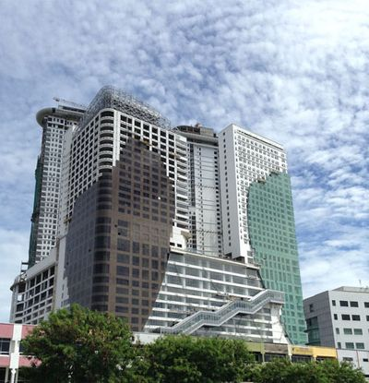


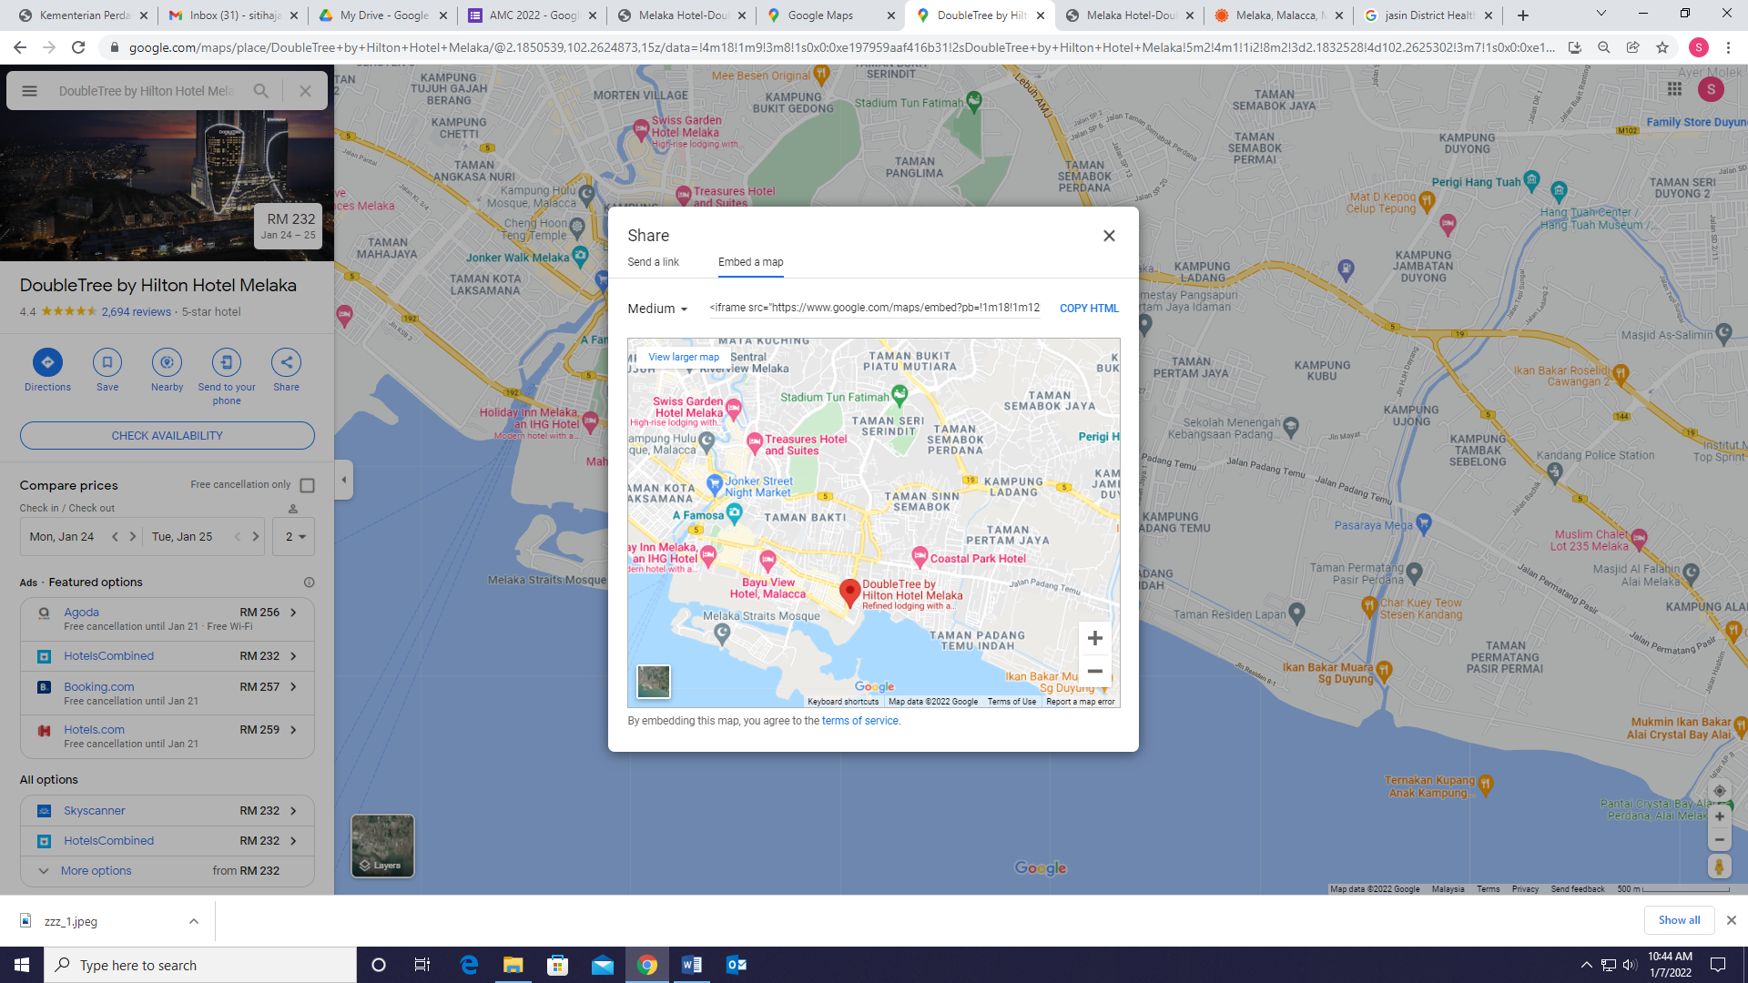
Latitude, Longitude : 2.1830019944123, 102.26222233615
Google Maps : https://g.page/DoubleTreeMelaka?share
Waze : DoubleTree by Hilton Melaka

Participants
Due to the current COVID-19 situation, representative from each Working Group is limited to a maximum of two (2) persons. Please confirm your attendance latest by 5.00 PM, Thursday, 20 January 2022 through the link below:
RSVP: https://forms.gle/ebuh9yTsn7TA6rED7

Accommodation
Please note that the participants’ accommodation is not provided by the organiser. It is suggested for the AMC2022 participants to manage your accommodation accordingly. If you are interested to stay at the DoubleTree by Hilton Melaka, you are entitled to the special rates offered as below (first come first serve basis and subject to room availability):

Room Category Rate
- Guest Room (Single Occupancy) : RM 336.40 nett / room / night
- Guest Room (Double Occupancy) : RM 359.60 nett / room / night

To make a reservation, participants may email directly and quote MITI in your email to the Reservation Department at MKZMM_RES@hilton.com.

Alternatively, you could also make a reservation directly via the hotel’s website or third-party websites / online travel agents (Agoda, Booking.com, etc.).

Dress Code
The dress code for AMC2022 is business casual.

Parking
Parking for Hotel Guest is complimentary at the DoubleTree by Hilton Melaka.
Parking for Non-Guest is available with rates as below:

Normal Ticket | Fee (per entry)
Weekday | RM3
Weekend | RM5
Valet Parking | RM30

Amenities
LEVEL | FACILITIES
14-28 | Guest Rooms
13 | Grand Ballroom  Straits Meeting Rooms  Tosta Trattoria  Fitness Centre by Precor  Infinity Pool  Sauna & Steam Room  Kids Club
12 | Hotel Lobby - Reception  Makan Kitchen  Axis Lounge
11 (Mall) | MBO Cinema
5-9 | Parking
GF | Hotel Lobby - Concierge

Weather Forecast
First Day – 25 January 2022 (Tuesday)

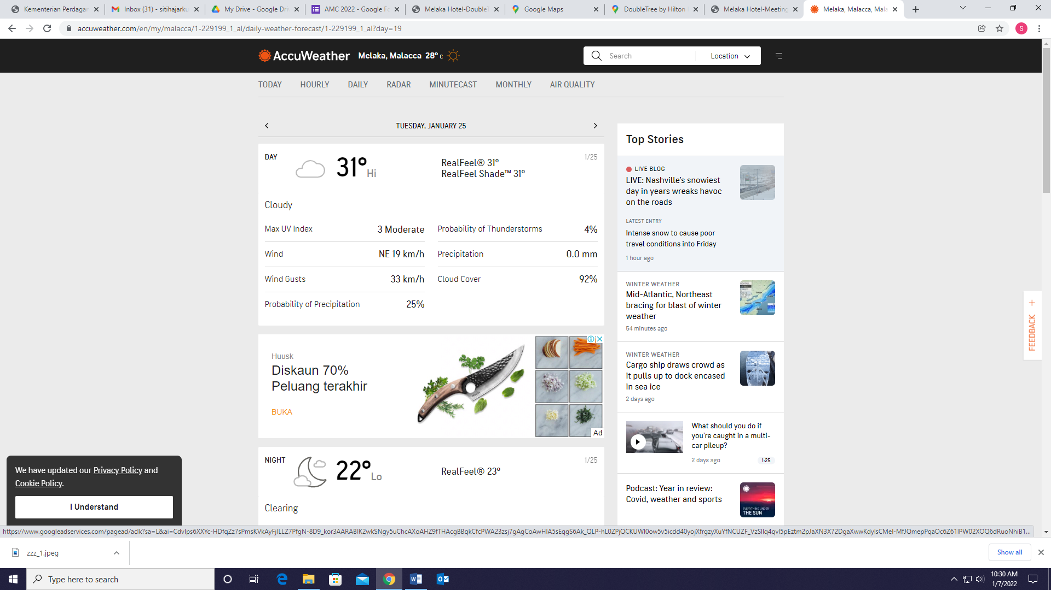

Second Day – 26 January 2022 (Wednesday)

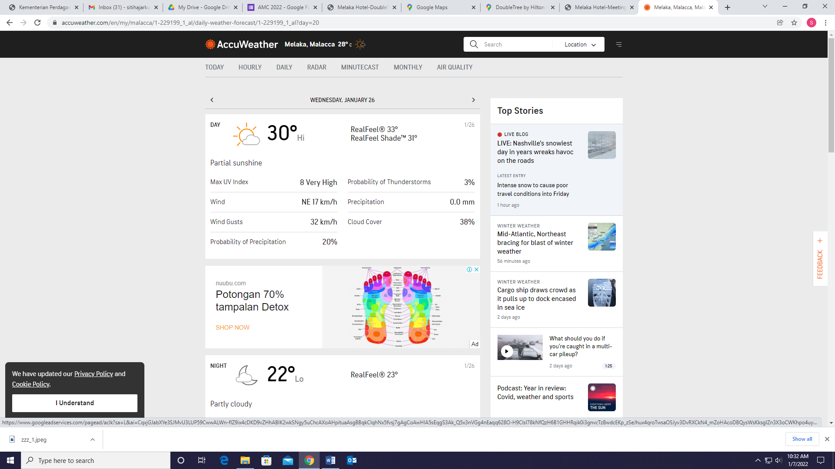

Etiquette
Due to the current pandemic situation, all participants are required to adhere and comply to the general SOPs and guidelines by the National Security Council (MKN). Only fully vaccinated individuals are allowed to participate in this Conference and participants are also encouraged to undergo appropriate COVID-19 test assessment.

Participants are required to practice mandatory preventive and protective measure to minimise risks related to the spread of COVID-19. In this regard, participants are advised to adhere to the following measures throughout the Conference:

- Record your body temperature at the registration counter and scan MySejahtera bar code prior to entering event hall;
- Wear mask during all sessions;
- Practice physical distancing; and
- Regularly apply hand sanitizers. (Hands sanitizers dispenser can be found at any key entrances and common areas in the hotel).

For more details on SOPs and guidelines, please refer to the following sites:

- MKN Website:
https://asset.mkn.gov.my/web/wp-content/uploads/sites/3/2019/08/Pelan-Pemulihan-Negara-SOP-Fasa-4-Kemas-Kini-7-Disember-2021.pdf

You are also advised to switch off your mobile phone/s or switch it to silent mode throughout the Conference.

It is also strictly advised that no recordings and photo takings are allowed during any sessions.

Emergency Evacuation
In the event of fire or emergencies during the course of the event, please follow the emergency evacuation plan of the venue.

Emergency Contact Number:

DoubleTree by Hilton Melaka : 06-222 3333 (General Line)

Other Emergency Contact Number:

Melaka Hospital : 06-289 2344

Jasin District Health Office (PKD) : 06-529 1333

Banda Hilir Police Station : 06-284 5222

Padang Temu Fire and Rescue Station : 06-268 3103

Disclaimer
The organiser shall not be held responsible for any injury, loss or mishaps that may occur during the event. All participants are responsible for their own safety and personal belongings throughout the two-day event.

Organising Committee Details
Should you have further enquiries, please feel free to reach the committee at:

Mohd Fauzi Mohamad Kudong : 016 605 7073
Nurul Alia Razani : 019 664 4623
Mohd Zulfadhli Rosli : 012 360 9326
Mohammad Mifzal Md Radzi : 019 567 4863

Prepared by:
APEC Division
Ministry of International Trade and Industry
Email: apecmiti@miti.gov.my

Copyright©: APEC, MITI

