1.0 Kos Program
Item | Kadar Sehari (RM) | Jumlah Keseluruhan (RM)
Yuran Penyertaan  (Yuran RM 20,000 adalah untuk 25 peserta bagi 2 hari program) | - | 20,000.00
Pengangkutan | - | 4,000.00
JUMLAH |  | 24,000.00

2.0 Senarai Peserta:

BIL. | NAMA | BAHAGIAN
1 | Norhaniza Hamir | NC
2 | Mohd Hilmi Idris | NC
3 | Nuraizah Harun | NC
4 | Shahriza Bahari | NC
5 | Nurul Ain Alia Abdullah Zawawi | NC
6 | Najiyah Md Zaliki | NC
7 | Azlin Alias | NC
8 | Darul Adizul Ishak | NC
9 | Cham Yin Hwa | NC
10 | Norhasimah Ibrahim | NC
11 | Izzul Ikhwan Ishak | NC
12 | Putri Dhia Nathasya Mohammad Yusoff | NC
13 | Norliana Mahmud | TDS
14 | Shahidah Shamsuddin | TDS
15 | Siti Sakinah Mohd Zaki | TDS
16 | Nur Munirah Mustaffa Kamal | TDS
17 | Ellma Eddiahwati Musa | TDS
18 | Nor Halisa Mohamad Halil | DMO
19 | Azimah Adnan | DMO
20 | Lee Wan Wei | DMO
21 | Safura Abdul Malek | DMO
22 | Ahmad Mursyidi Adzmi | DMO
23 | Wan Rozita Ma’al | Negeri Produktif
24 | Dr. Faridah Taju Rahim | BTI
25 | Raja Ainul Bismi Raja Abd Hadi | BTI

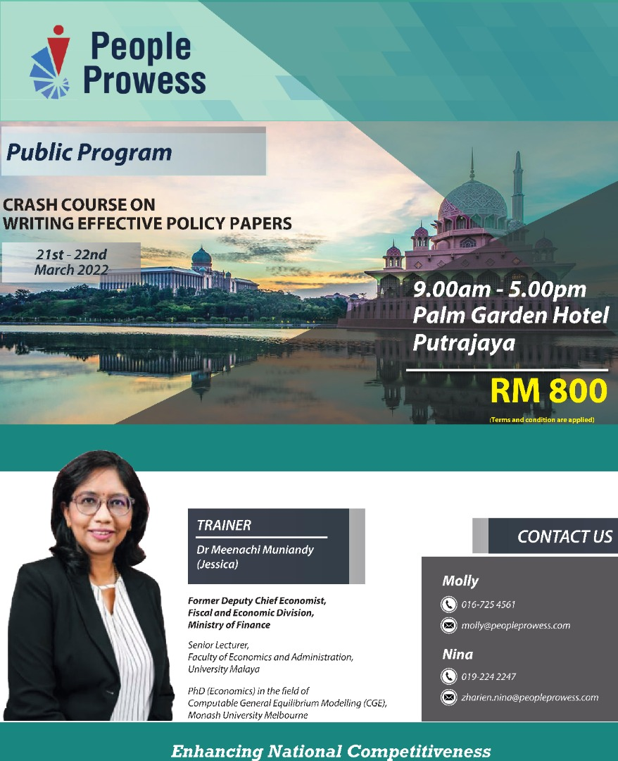

Crash Course On Writing Policy Paper

Overview

- A policy paper presents a concise summary of information that can help policy makers understand, and likely make decisions about, government policies. Policy briefs may give objective summaries of relevant research, suggest possible policy options, or go even further and argue for particular courses of action.

- An effective policy brief must propose a solution to a well-defined problem that can be addressed at the level of policy.

- Therefore, writing an effective Policy Paper is imperative to communicate the ideas/suggestions/recommendations/comments clearly, without unnecessary jargons and coherently to the policy/decision makers.

Learning Objective

- This crash course will teach the basic strategies, mechanics and structure of policy papers.

- Policy papers provide a decision maker with an overview of an issue or problem, targeted analysis and often, actionable recommendations.

Targeted Audience

- For those who are involved in advising policy makers with recommendations or providing comments on certain public policies.

Duration

- 4 days @ 4 hours

Methodology

Lectures and Group Exercises

Language: Policy paper (English) and Memorandum Jemaah Menteri (BM).

Course Outline

Core components of this course will cover the following:

- The Executive Summary;

- Introduction/Background;

- Methodology;

- Literature Review;

- Analysis of Findings or Evidence;

- Policy Options and Recommendations;

- Implementation and Next Steps;

- Conclusion;

- Appendices;

- Bibliography; and

- Presentation to the decision makers

Trainer Profile

Dr Meenachi Muniandy (Jessica)
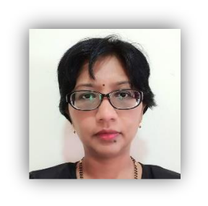

EDUCATION

- Bachelor in Economics, University Malaya (1996)

- Diploma in Public Administration, Intan Bukit Kiara (2001)

- Master in Public Policy (Economics), GRIPS, Japan (2007)
Project Paper “Foreign Direct Investment in Malaysia: An Econometric Analysis of the

Determinants, 1985-2005

- Ph.D in Economics, Monash University (2015)
Thesis: Assessing the economic impact of public investment in Malaysia: A case study on MRT using a computable general equilibrium (CGE) model

EMPLOYMENT

- 1996 – 2001 Administrative Officer

Moritetsu Electric (M) Sdn. Bhd.

In charge of human resource matters of about 400 employees
In charge of account and administrative matters of the firm

- 2001 – 2006 Assistant Secretary

Economics and International Division

Ministry of Finance Malaysia

Section: International (APEC and ASEM)

  - Attended Finance Ministers Meetings and Working Group Meetings under the purview of APEC and ASEM

  - Wrote speeches and talking points as well as background information for Ministers

  - Wrote the outcomes of attended international meetings in the Annual Economic Report

  - Organised meetings and forums

- 2006 – 2007 Further studies (Master in Public Policy [Economics], GRIPS Japan)

- 2007 – 2011
Principal Asst. Secretary (Demand) Economics and International Division Ministry of Finance Malaysia

  - Monitored Economic Performance in terms of demand, i.e. Consumption and Investment

  - Forecast Economic Growth

  - Wrote Annual Economic Report: Quarterly and Annually

  - Conducted analysis and studies to enhance investment and consumption activities

  - Prepared answers for Parliament

  - Prepared inputs on economic performance for Ministers of Finance

  - Wrote box article on Rising Food Prices in the 2006 Economic Report

- 2011 – 2015 Further studies (PhD in Economics, Monash Australia)

- 2015 – 10 Dec 2017
Head of Section (Domestic Demand) Macroeconomics

Fiscal and Economics Division Ministry of Finance Malaysia

    - Forecast economic growth

    - Write Annual Economic Report: Quarterly and Annually

    - Conduct economic analysis on government policies using computable general equilibrium model such as the impact of high oil prices, the impact of ringgit depreciation, the impact of cut in government expenditure, etc.

    - Write policy papers on economic issues

    - Prepare answers for Parliament questions/debate

    - Provide comments on Cabinet Meetings

    - Prepare inputs/slides on current economic scenario including external environment

- Prepare inputs and attend meeting with economic analysts such as Moody’s,

Fitch, BNP Paribas, World Bank, IMF, OECD, ADB and AMRO

- Conduct economic and CGE classes for MOF officers

- Conduct Talks and Seminars when required

- Head of Budget Speech Translation Team

- Covering Head of Section (Supply)
- Forecast GDP from supply side

- Prepare inputs related to agriculture, construction, mining and manufacturing

    - Prepare monthly report on IPI and quarterly report on property

- 11 Dec 2017 –

Deputy Chief Economist (Macroeconomics) Fiscal and Economics Division
Ministry of Finance Malaysia

  - Oversee economic growth forecast

  - Edit write up on articles in Economic Outlook (Quarterly and Annually)

  - Participate in discussions with economic analysts such as Moody’s, Fitch, BNP

Paribas, World Bank, IMF, OECD, ADB and AMRO

  - Oversee writing of policy papers and present to top management/ministers

  - Prepare inputs/slides on current economic scenario including external environment

  - Organise events such as Budget Consultation and Focus Group Meetings

  - Write speech and talking points for top management

  - Conduct economic and CGE classes for MOF officers

  - Conduct talks and seminars when required

  - Conduct economic analysis on government policies using computable general equilibrium such as the impact of rationalisation of petrol subsidy and the impact of cash transfer

COURSES / TRAINING CONDUCTED

- The Asian Financial Crisis (1997) and the Global Financial Crisis (2008): Lessons for Malaysia – Taylors College (28 Nov 2015)

- Economic Theory for Computable General Equilibrium (CGE) – MOF (12 Sept 2015)

- Dynamic Equations for CGE – MOF (24 Nov 2015)

- Preparation for Dynamic CGE course – MOF (27 Nov 2015)

- Dynamic Computable General Equilibrium – MOF (30 Nov – 4 Dec 2015)

- Current Economic Scenario – Understanding ringgit depreciation – Kolej Mara Banting (6 Jan 2016)

- Understanding Economic Indicators – INSPEN (15 March 2016)

- Understanding Economic Indicators –Malaysian Rubber Export Promotion Council (28 Feb 2017)

- Economic Integration – Nottingham University (February – May 2017 )
- Dynamic CGE Modelling for Practical Policy Analysis (14 –18 January 2019)

AWARDS

- Excellence in Service (2003)

- Deans Award (2007)

- Excellence in Service (2009)

