KERTAS CADANGAN UNTUK PERTIMBANGAN
LEMBAGA PENGURUSAN MPC (BOM)

TAJUK  Keterangan: Tajuk Projek/ Cadangan | Capacity Building: Good Regulatory Practice Benchmarking with the Republic of Korea and Senior Official Bilateral Meeting on IPEF.
TARIKH/ GARIS MASA  Keterangan: Jadual mula dan akhir pelaksanaan projek/ cadangan | 9th – 19th July 2023
TUJUAN & LATAR BELAKANG  Keterangan: Tujuan dan penerangan ringkas mengenai projek | - In accordance with the Cabinet decision on April 27, 2022, Malaysia has officially joined the Indo-Pacific Economic Framework (IPEF) initiative. The Ministry of Investment, Trade, and Industry (MITI) has been appointed as the national coordinator for the IPEF negotiation process. Furthermore, MITI has designated MPC as the Lead negotiator for the Good Regulatory Practice Chapter (Appendix 1).  - As part of capacity building and knowledge exchange for regulatory reform programs, a Malaysian delegation will be organising a benchmarking session with the Republic of Korea. This includes meetings with the South Korea Office of Legal Counsel, Ministry of Justice, the Regulatory Reform Committee under the Office for Government Policy Coordination, Prime Minister's Secretariat. The Planning and Coordination Office (Regulatory Reform), Ministry of Land, Infrastructure and Transport. The purpose of this engagement is to learn and exchange best practices and perspectives. Details itinerary as per Appendix 2.
JUSTIFIKASI  Keterangan: Penjelasan yang menyokong kepada pelaksanaan projek/ cadangan | - Regulatory provisions have gained prominence in recent regional trade agreements (RTAs), reflecting their growing importance. MPC assumes a pivotal role as the lead regulatory oversight body entrusted with overseeing the implementation of the National Policy on Good Regulatory Practice (NPGRP). The GRP Chapter under IPEF Pillar 1 holds significant relevance for the MPC, serving to position its function and interests, while also safeguarding Malaysia's sovereignty.  - The successful conclusion of the GRP chapter, in alignment with Malaysia's adoption and level of readiness in implementing GRP principles, can establish an enabling regulatory environment. This environment would foster sustainable economic growth and facilitate mutually beneficial trade relations among the participating countries.  - In order to enhance capacity building and facilitate the exchange of knowledge on regulatory reform programs, a delegation from Malaysia will be organising a benchmarking session with the Republic of Korea. This session will involve meetings with key institutions, including the South Korea Office of Legal Counsel, Ministry of Justice, Regulatory Reform Committee under the Office for Government Policy Coordination, Prime Minister's Secretariat, and the Planning and Coordination Office (Regulatory Reform), Ministry of Land, Infrastructure and Transport.  - The primary objective of this engagement is to foster a learning environment and facilitate the exchange of best practices and perspectives between the two countries. By studying and sharing experiences, both Malaysia and the Republic of Korea aim to strengthen their regulatory frameworks and enhance their approaches to regulatory reform.
KAEDAH PELAKSANAAN  Keterangan: Kaedah yang perlu dilakukan bagi melaksanakan projek | Sebut Harga (Perolehan Perkhidmatan Melebihi RM100 ribu hingga RM500 ribu)
STAKEHOLDERS/ PIHAK BERKEPENTINGAN  Keterangan: Pihak atau kumpulan yang menerima kesan positif mahupun negatif daripada projek yang dijalankan | - Cabinet  - MITI, AGC  - Ministries and Regulatory Agencies  - Businesses
JANGKAAN HASIL/ OUTCOME  Keterangan: Apa yang MPC perlu capai/ faedah-faedah jangka pendek dan jangka panjang hasil dari intervensi projek/ cadangan | - Enhance comprehension of the context, scope, and criteria to be addressed in the Good Regulatory Practice (GRP) chapter, as well as assess the readiness of IPEF member countries regarding GRP.  - Ensure effective implementation of Malaysia's commitment to the topic of Good Regulatory Practice (GRP) and guarantee its successful realisation.  - Delve into strategic discussions pertaining to national interests associated with GRP, allowing for a comprehensive examination and determination of the most suitable approach.  - Malaysia and the Republic of Korea exchange best practices and experiences to strengthen their regulatory frameworks and enhance regulatory reform approaches. This collaboration fosters knowledge-sharing and continuous improvement in regulatory governance.
JANGKAAN OUTPUT  Keterangan:Output ketara dan tidak ketara yang dihasilkan daripada aktiviti projek/ cadangan. | Review Report on the Good Regulatory Practice (GRP) Chapter and Benchmarking Report
KUMPULAN SASAR  Keterangan: Individu/ kumpulan yang menerima faedah daripada projek/ cadangan | - Cabinet  - MITI  - Ministries and Regulatory Agencies  - Businesses
SUMBER BAJET/ KOS  Keterangan: Sumber bajet / jumlah kos yang terlibat. | Detailed information on the estimated expenditure costs can be found in Appendix 3.
  Budget Allocation | RM
  Development (DE) | 165,000.00
  Operation (OE) | 11,873.05
  TOTAL | 176,873.05
HASIL (RM) - SEKIRANYA ADA  Keterangan: Pendapatan yang diterima daripada projek | n/a
SYOR  Keterangan: Keputusan yang diperlukan daripada Lembaga Pengurusan MPC | Board of Management (BOM) to approve the proposed list of delegates for the Capacity Building Program: Regulatory Reform Program Benchmarking with the Republic of Korea and Senior Official Bilateral Meeting on IPEF with the estimated cost for this program is RM176,873.05
UNIT/ BAHAGIAN | NCS/PCD

**Sila lampirkan maklumat-maklumat lain yang berkaitan sekiranya perlu.
(Contoh: Agenda program, perincian kos, pelan risiko, gambar rajah, lakaran pelan, senarai nama, carta Gantt, dll.)

Hanya untuk permohonan yang menggunakan Bajet Pembangunan dari Unit/Bahagian lain.
Kolum ini boleh diabaikan sekiranya tidak berkaitan.
DISOKONG OLEH:

PEGAWAI PENJAGA BAJET PEMBANGUNAN
Wan Fazlin Nadia Wan Osman
Jawatan: Pengarah
Nama Bajet: Pembangunan FORE
Tarikh: 31 May 2023

**Wajib diisi | **Wajib diisi | Permohonan memadai disemak sehingga peringkat Penyelia. Kolum ini boleh diabaikan sekiranya tidak berkaitan
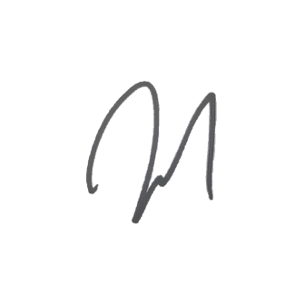  DISEDIAKAN OLEH:  NAMA PEMOHON  Mohd Zulkifly Che Mohd Rawawi  Pengurus  Tarikh: 31 May 2023 | 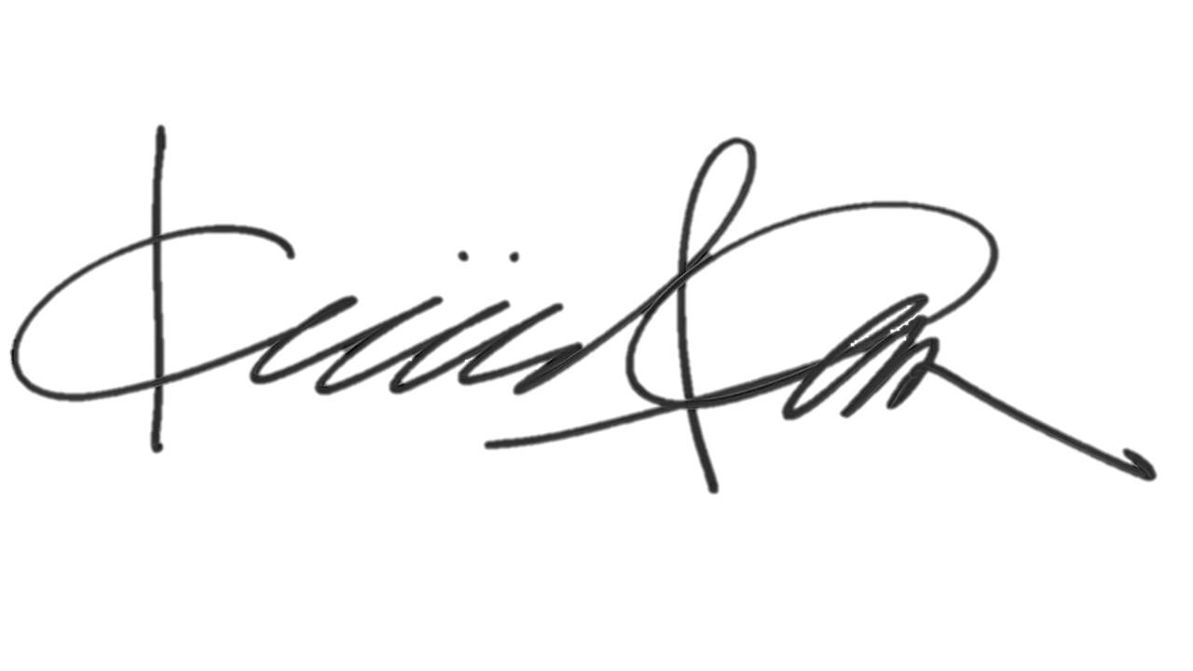  DISEMAK OLEH:  NAMA PENYELIA  Mohd Khairil Anuar Amir Hamzah  Pengurus Kanan  Tarikh: 31 May 2023 | DISAHKAN OLEH:  NAMA PENGARAH  Mohammed Alamin bin Rehan  Pengarah  Tarikh: 31 May 2023

