Senarai Cadangan Aset untuk di lupus 2023
No | No Pendaftaran Aset | Keterangan Aset | Unit | Gambar
 | MPC(SKO)ICT/H2008/01(1-5)  MPC(SKO)ICT/H2008/01(2-5)  MPC(SKO)ICT/H2008/01(3-5)  MPC(SKO)ICT/H2008/01(4-5)  MPC(SKO)ICT/H2008/01(5-5) | KOMPUTER HP COMPAQ 6520s | 5 | 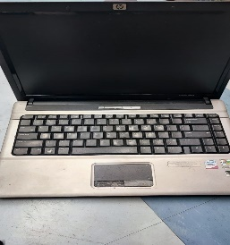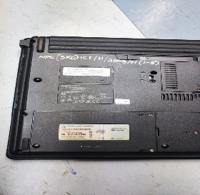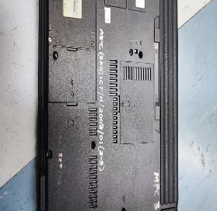  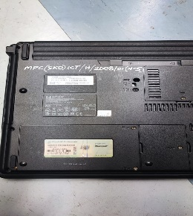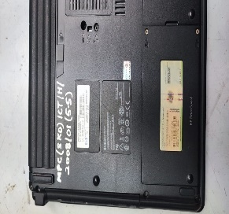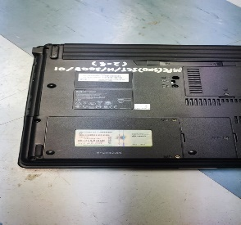
 | NPC/WSW/HM4/98(M)1 | PERALATAN GIMNASIUM – STEPPING MACHINE (PROTEUS ISS-200) | 1 | 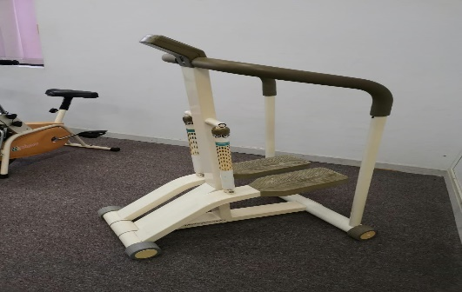
 | NPC/WSW/HM5/98(M)1 | PERALATAN GIMNASIUM – AIR WALKER (PROTEUS) | 1 | 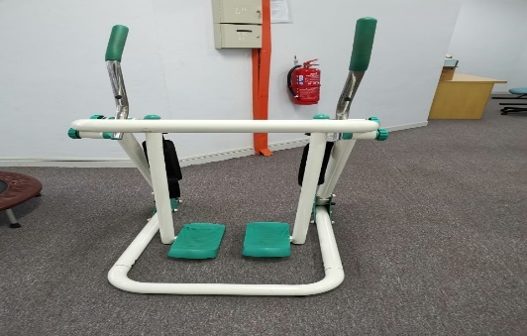
 | NPC/WSW/HM1/98(M)1 | PERALATAN GIMNASIUM – PROTEUS STUDIO 3 HOME GYM (PROTEUS) | 1 | 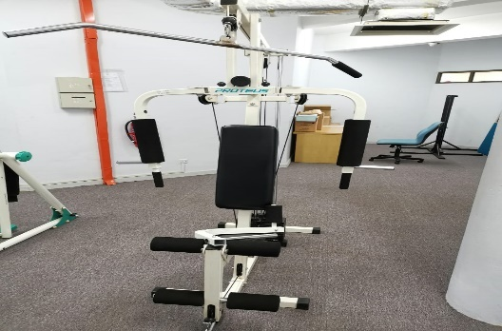
 | NPC/WSW/HM2/98(M)1 | PERALATAN GIMNASIUM – FREE WEIGHT BENCH | 1 | 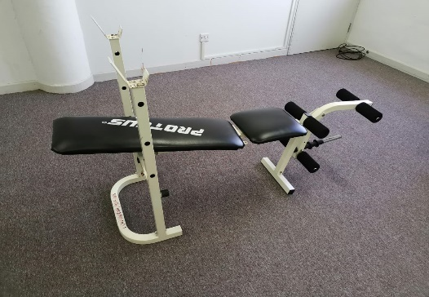
 | NPC M168/2004/168 | VIDEO CAMERA DCR DVD101 | 1 | 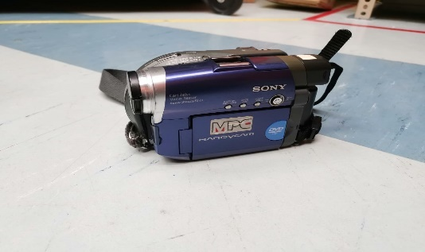
 | NPC(SKO)H/2007/09 | LCD PROJECTOR - BENQ | 1 | 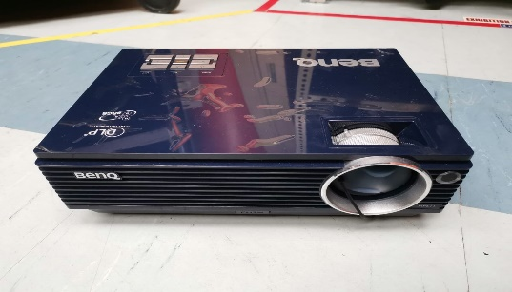  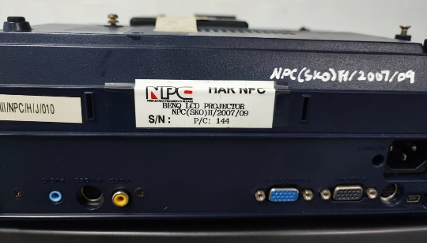
 | NPC/WSW/HM11/98(M) | VCR / VCD PLAYER MODEL - SONY | 1 | 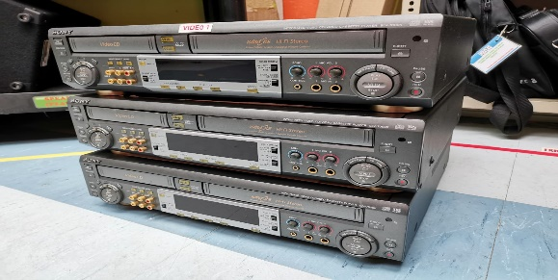
 | NPC/WSW/HM12/98(M) | VCR / VCD PLAYER MODEL - SONY | 1
 | NPC/WSW/HM13/98(M) | VCR / VCD PLAYER MODEL - SONY | 1
 | NPC/WSW/HM14/98(M) | TELEVISYEN – TV SONY 29’ MODEL KV – J29MF8S | 1 | 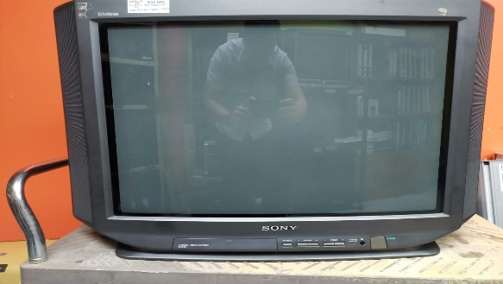
 | NPC/WSW/HM15/98(M) | TELEVISYEN – TV SONY 29’ MODEL KV – J29MF8S | 1
 | NPC/WSW/HM16/98(M) | TELEVISYEN – TV SONY 29’ MODEL KV – J29MF8S | 1
 | NPC/WSW/HM17/98(M) | TELEVISYEN – TV SONY 29’ MODEL KV – J29MF8S | 1
 | NPC/WSW/HM55/01(M) | HITACHI CORDLESS DRIVER DRILL FDS 12 DVA | 1 | 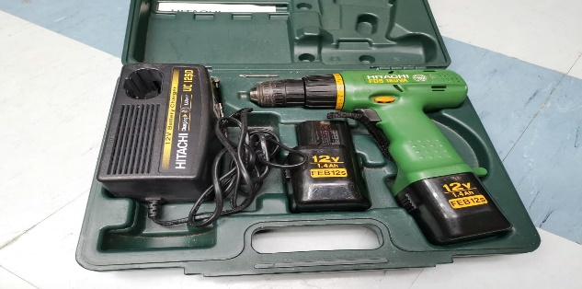
 | MPC/MSO/I/12/17 | CAMERA CANON (IXUS) 16.1 MEGA PIXELS | 1 | 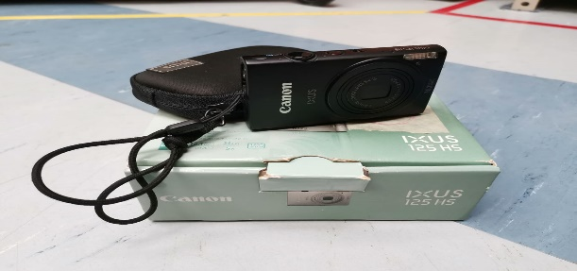
 | MPC(SKO)I/03/2014 | PENYIARAN/CCTV MONITORING SYSTEM (I-SECURE INFRARED DOME CAMERA) | 1 | 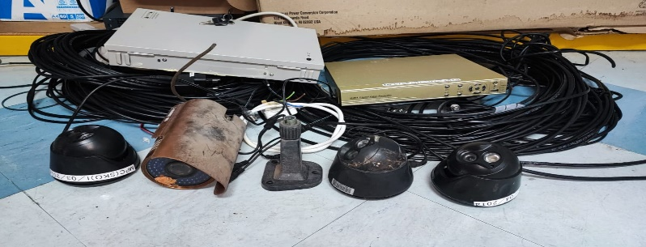
 | MPC(SKO)I/04/2014 | PENYIARAN/CCTV MONITORING SYSTEM (I-SECURE INFRARED DOME CAMERA) | 1
 | MPC(SKO)I/05/2014 | PENYIARAN/CCTV MONITORING SYSTEM (I-SECURE INFRARED DOME CAMERA) | 1
 | MPC(SKO)I/06/2014 | PENYIARAN/CCTV MONITORING SYSTEM (I-SECURE INFRARED OUTDOOR WEATHERPROOF CAMERA) | 1
 | MPC(SKO)I/07/2014 | PENYIARAN/CCTV MONITORING SYSTEM (I-SECURE DIGITAL VIDEO RECORDER (DVR) | 1
 | MPC(SKO)I/08/2014 | PENYIARAN/CCTV MONITORING SYSTEM (POWER SUPPLY 10A 8 CHANNEL) | 1
 | MPC(SKO)I/24/2014 | BOSCH AQUATAK 37-31 PLUS CLEANER (WATER JET) | 1 | 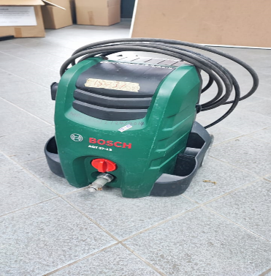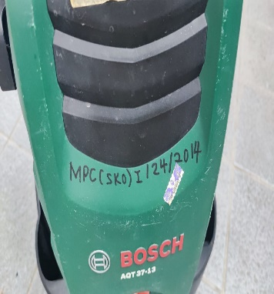
 | MPC(SKO)I/25/2014 | DBH Hand Blower | 1 | 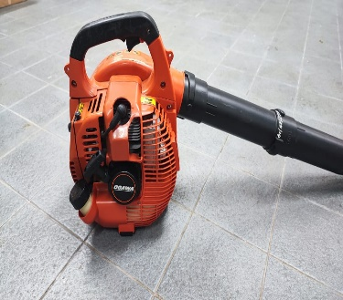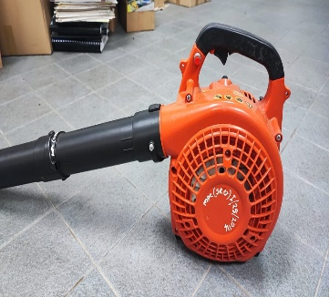
 | MPC(SKO)I/2013 (00503) | UV Pond Filter | 1 | 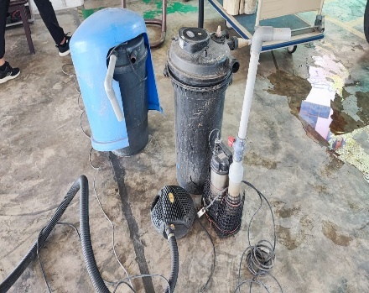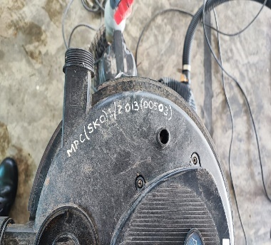
 | NPC/WSW/26/98(P)01-07 | Perabot  Side Table | 7 | 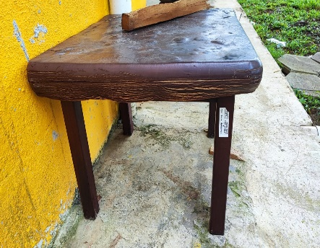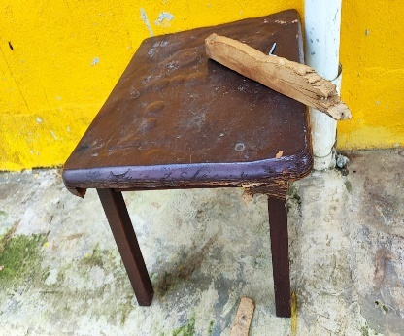
 | NPC/WSW/54/98 (P) 01 | Trampoline 40” | 1 | 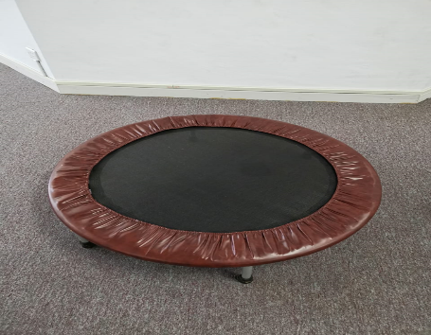
 | NPC/WSW/30/99(P) | Troli buku dengan rak sendeng | 1 | 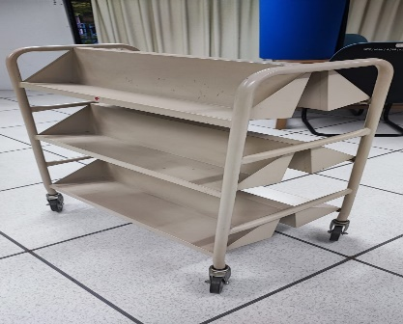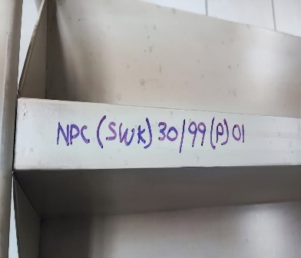
 | NPC/WSW/13/00(P) | Meja serbaguna  2’ X 3’ | 7 | 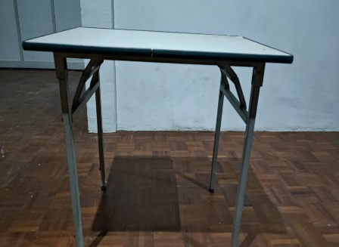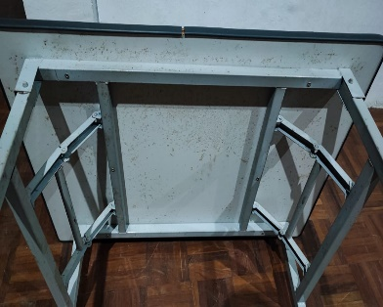
 | NPC/68/2005 | Plasma TV Floor Trolley WP-811 | 1 | 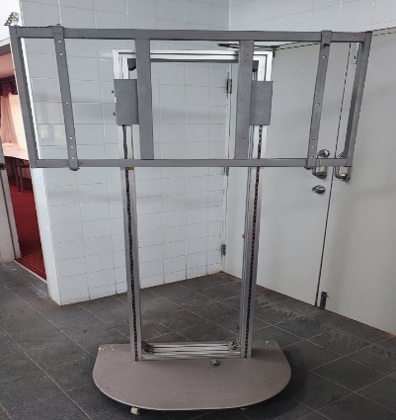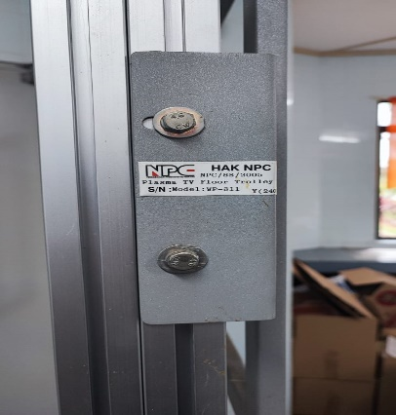
 | NPC(SKO)P13/2007(1-2)  NPC(SKO)P14/2007(2-2) | Weight Lifting Support Stand | 2 | 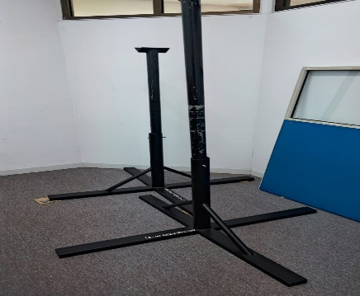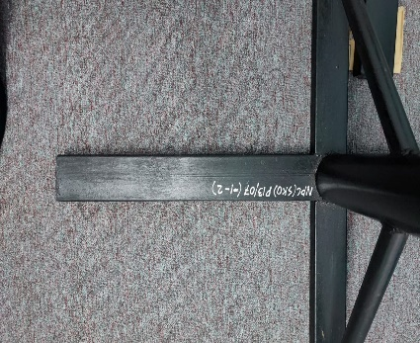  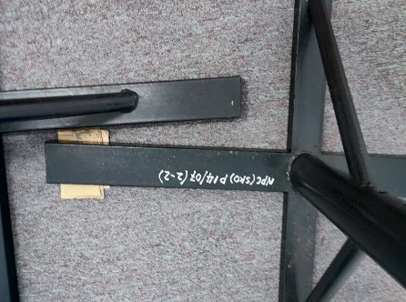
 | MPC(SKO)I/08/06(1-3)  MPC(SKO)I/08/06(3-3) | Maxtor 120GB External Hard Disk with USB 2.0 | 2 | 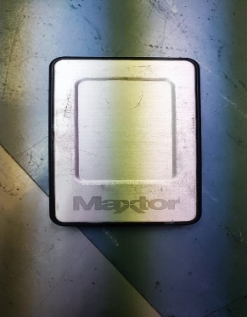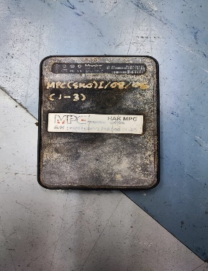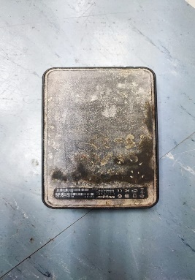
 | NPC(SKO)I/07/49 | Trolley – Size 73x45x80cm (1set) | 1 | 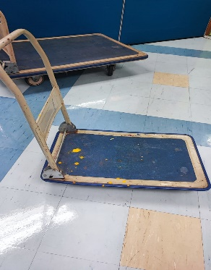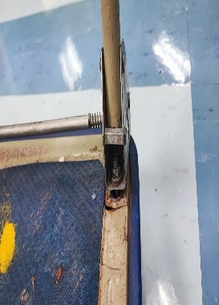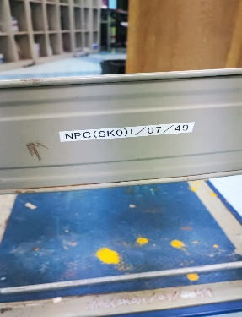
 | MPC/CSF/I/08/140 | M-Walker Webcam NV-506 | 1 | 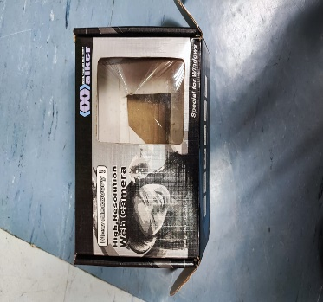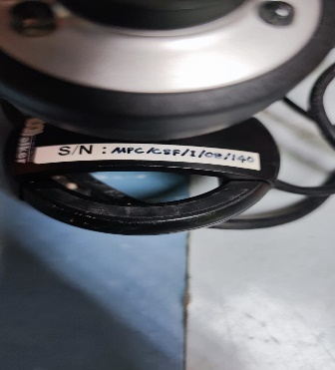
 | NPC(SKO)I/07/45 | Apex CH-1133 High Black Executive Chair (Blue) | 1 | 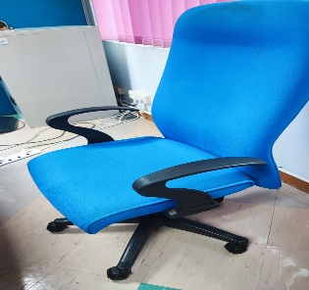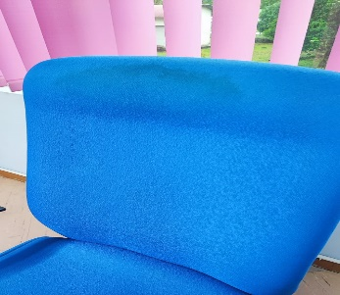
 | NPC(SKO)I/07/47(1-4)  NPC(SKO)I/07/47(2-4)  NPC(SKO)I/07/47(3-4)  NPC(SKO)I/07/47(4-4) | Apex ch 500E H/B Chair (blue.002) | 4 | 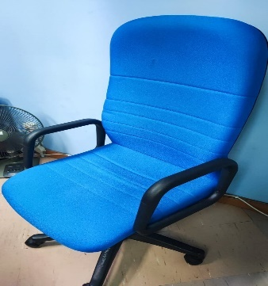
 | NPC/WSW/HM18/98/(M) | Copy Board  Electronic Copy Board | 1 | 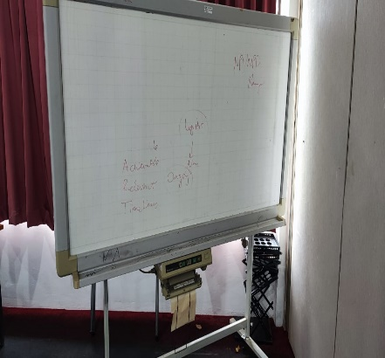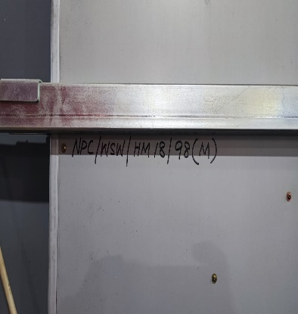
 | NPC/WSW/HM04/00(M) | DVD, VCD & CD Player  Sony DVD – S705S | 1 | 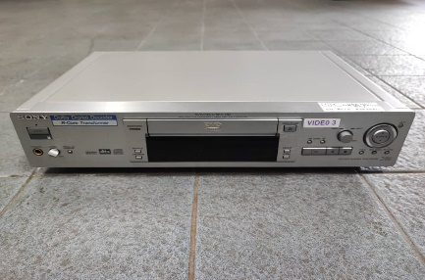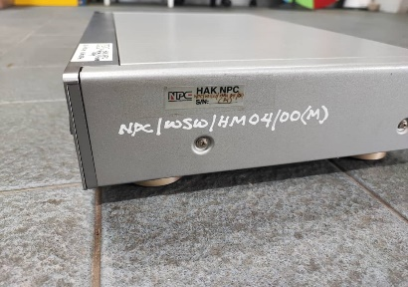
 | NPC/WSW/HM05/00(M) | Ampilifier  Power AV – Dolby Digital (AC-3)  Sony STR – DH930ES | 1 | 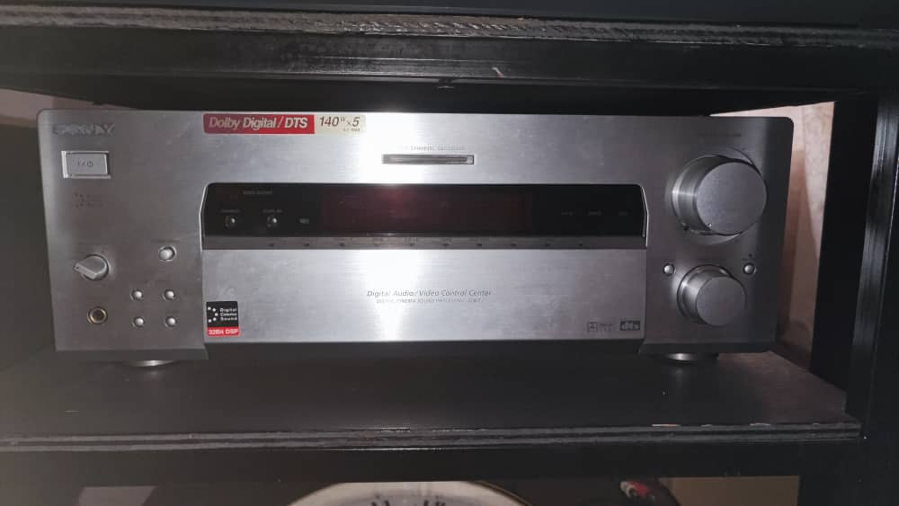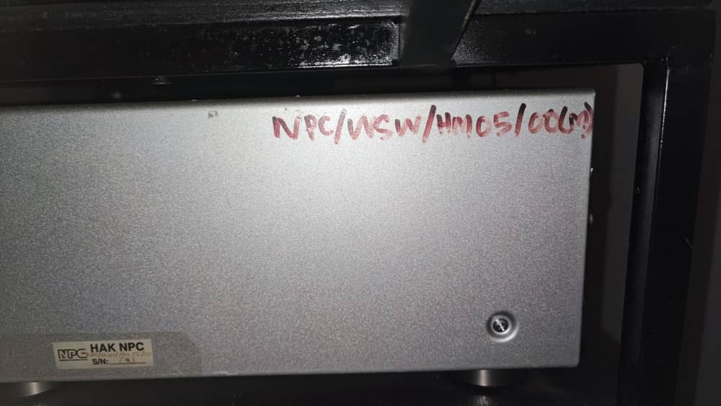
 | NPC/WSW/HM07/00(M)01 | Floor Type – 3 Way Speaker System  Sony SS –X9S | 1 | 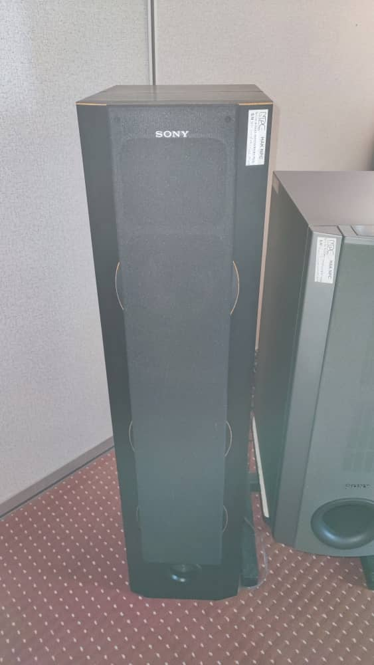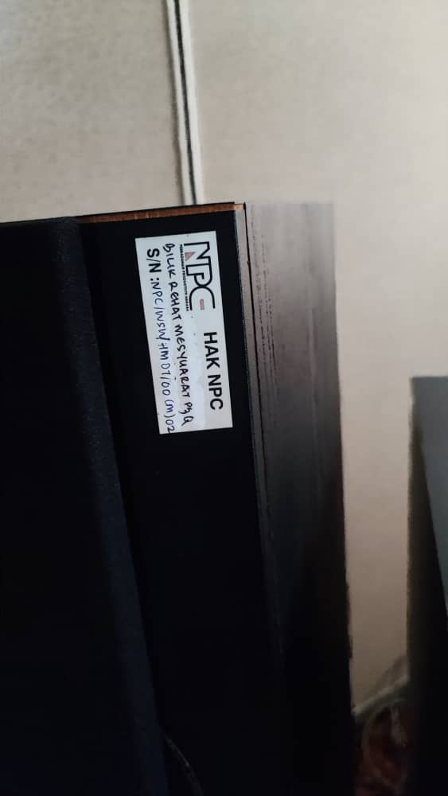
 | NPC/WSW/HM08/00(M)02 | Floor Type – 3 Way Speaker System  Sony SS –X9S | 1 | 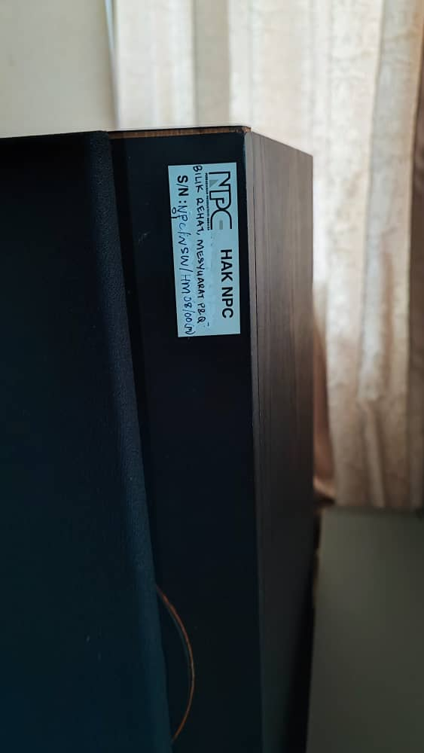
 | NPC/WSW/HM/25/00(M)04-06  NPC/WSW/HM/25/00(M)05-06 | Penghawa Dingin (1 Lot)  Acson RCM 50C – CCL / ALC50C | 2 | 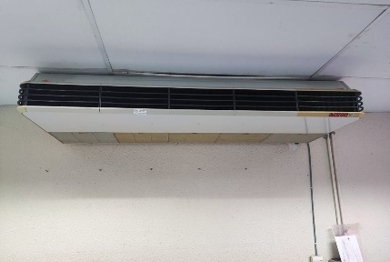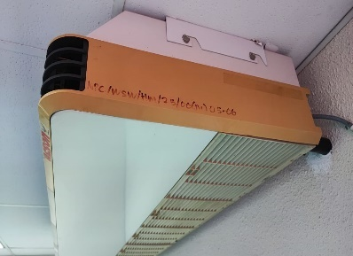  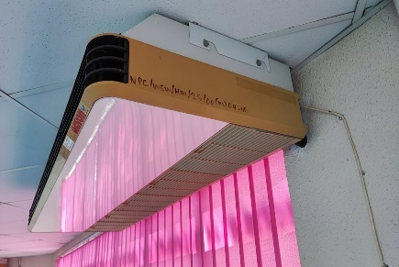
 | NPC/WSW/HM/33/2000(M) | Wireless Sennheiser / 1083 VHF | 1 | 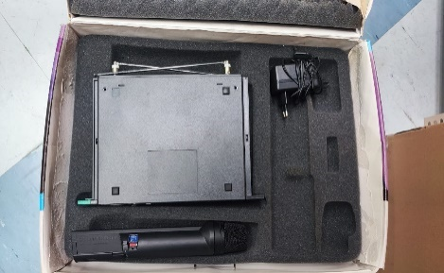
 | NPC(WSW)HM44/00(M) | Handheld Wireless Microphone  Sennhieser/1081 VHF | 1 | 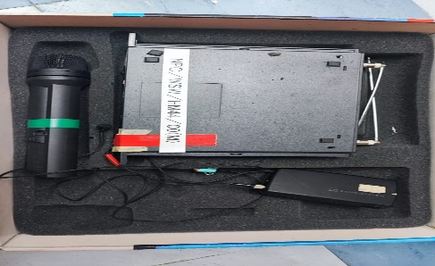
 | NPC/WSW/HM/45/00(M) | Handheld Wireless Microphone  Sennheiser/1083/VHF | 1 | 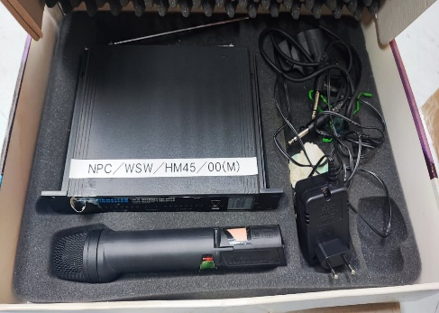
 | NPC/WSW/HM1/02 (M) | National Split Type / Ceiling Type Aircond Model CS/CU 1800 TH (18,000 BTU) | 1 | 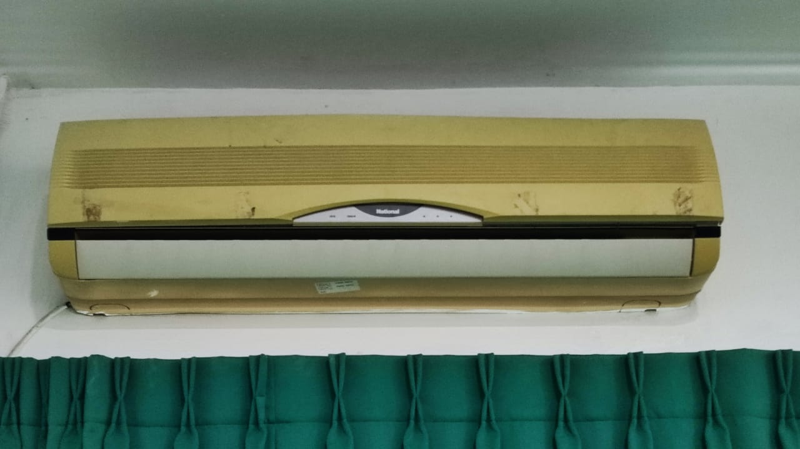
 | NPC/M29/2005/29 | Plasma Display  PPM63H3Q | 1 | 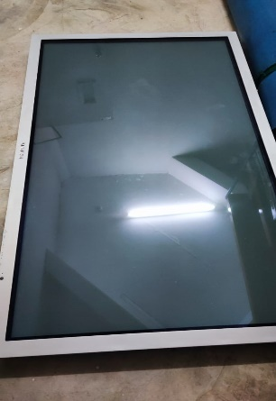
 | NPC(SKO)HM05/2007(1-2)  NPC(SKO)HM06/2007(2-2) | Aircond Wall Mounted 24000 BTU / YORK / YSL25C-AMPOD / YW25G-AmlBA (ess) | 2 | 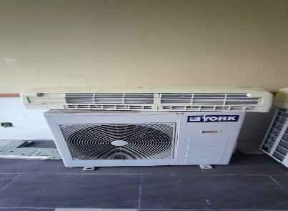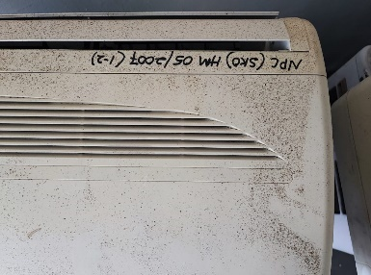  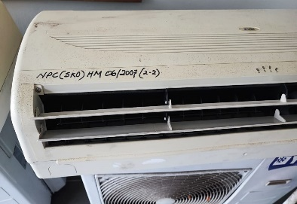
 | NPC(SKO)H/2007/14 | Server  HP Proliant ML350 | 1 | 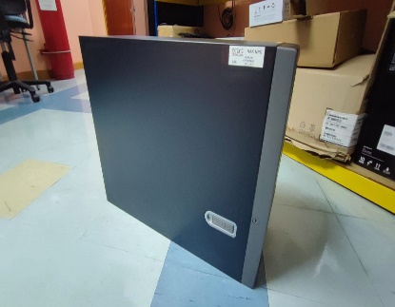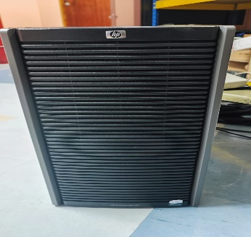
 | MPC(SKO)ICT/H/2009/01/(1-3)  MPC(SKO)ICT/H/2009/01/(2-3)  MPC(SKO)ICT/H/2009/01/(3-3) | LCD Projector  Hitachi CPX401 LCD Projector | 3 | 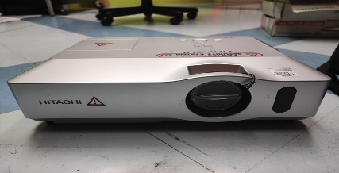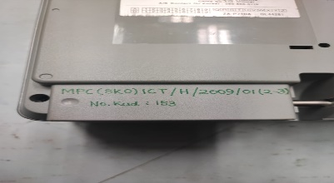  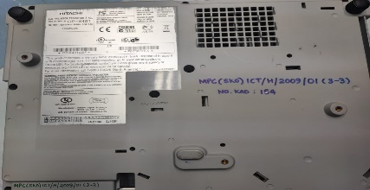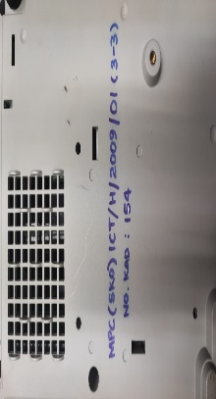
 | MPC/MSD/H/212/40 | Projector Panasonic PT-LB3EA  (Myke) | 1 | 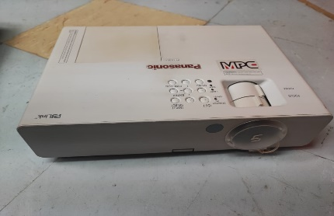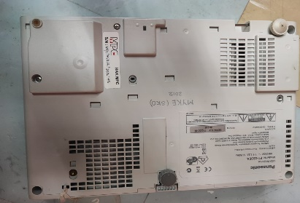
 | MPC(SKO)ICT/H/2012(06) | Dell Optiplex 360 | 1 | 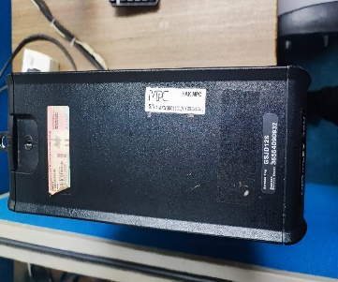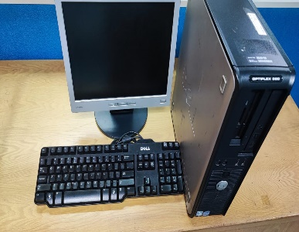
 | MPC/MSD/H/2014/18 | Printer Epson LQ2190 | 1 | 