KERTAS CADANGAN UNTUK PERTIMBANGAN
LEMBAGA PENGURUSAN MPC (BOM)

TAJUK  Keterangan: Tajuk Projek/ Cadangan | Laboratory tests on Black Soldier Fly Larva (BSFL) meal as an alternative source of protein for chicken feed.
TARIKH/ GARIS MASA  Keterangan: Jadual mula dan akhir pelaksanaan projek/ cadangan | August 2022 – December 2023
TUJUAN & LATAR BELAKANG  Keterangan: Tujuan dan penerangan ringkas mengenai projek | Chicken meat is considered the cheapest source of meat protein and the most popular among Malaysian consumers, largely because there are no dietary prohibitions or religious restrictions against meat consumption. Despite this, the industry is not sustainable in the long term due to heavy dependence on imported feed grains, mainly corn and soybean meal, which make up about 80% of the poultry diet. The sharp increase in feed grain prices led to the surge in chicken prices in the local market There is a need for local researchers to study the availability, nutritive value, and optimal inclusion levels of various locally available feed ingredients in poultry rations.  For this purpose, insects have been already proposed as a high quality, efficient and sustainable alternative protein source for poultry. The black soldier fly larvae (BSFL) are known to feed and develop on a wide range of feed sources, such as oil palm and agriculture wastes. BSFL meal as a poultry feed ingredient is still limited. The nutritive value of the BSFL may vary according to the quality of feedstock provided to support larval development. Thus, an in-depth study on locally produced BSFL meal in poultry is critical to promoting the sustainability of the Malaysian poultry industry.  Objectives  - To evaluate the proximate composition, amino acid profile, microbiological quality and heavy metal concentration of BSFL meal from various local sources  - To determine the apparent nutrient digestibility, metabolisable energy and apparent ileal amino acid digestibility of locally produced BSFL meal in chickens.  - To ascertain the effects of feeding locally produced BSFL meal on growth performance and economic efficiency in broiler chickens.
JUSTIFIKASI  Keterangan: Penjelasan yang menyokong kepada pelaksanaan projek/ cadangan | Rising food prices is a concern not only to consumers but also to the economy as it is a component of the indices that make up the country’s competitiveness, which has been on the decreasing trend. For the B40 and M40 income groups the rising cost of food compared to almost stagnant wages is burdensome since food comprises 24-29 % of their household expenditure. It is no surprise that PEMUDAH, a public-private sector collaborative arrangement formed a technical working group on food costs aimed at easing businesses in the supply chain and to translate savings into affordable food prices.  A comprehensive analysis of the chicken supply chain highlights the forces, both global and local which act adversely or positively on all parts, from input to farm levels and the very complex off-farm players comprising wholesalers, slaughterhouses, food processors, F&B and retailers. The increasing price of chicken is attributable to the rising cost of chicken feed which comprises almost 70% of the cost of production. Almost 90% of the sources of chicken feed (corn for energy and soya bean for protein) are imported. The prices of these two sources have been escalating, worsened by the Russia-Ukraine war. Intervention strategies to determine effective local sources of protein for chicken feed are not only crucial for keeping the poultry industry competitive and at the same time sustain the affordability of chicken but are important for ensuring the food security of the nation.  BSFL meal is known to possess high protein content and is locally produced. Its widespread adoption as a source of chicken feed is limited by prohibitive costs related to the small scale of production as well as untested nutritional content and effectiveness at the industrial level. Laboratory tests are needed to determine the nutritional content of locally produced BSFL meal, followed by industrial trials to determine the formulation and cost effectiveness. The tests are in line with Strategy 5, subsector on livestock in Dasar Agro-Negara (DAN 2.0)
KAEDAH PELAKSANAAN  Keterangan: Kaedah yang perlu dilakukan bagi melaksanakan projek | Research team:  Prof. Dato’ Dr. Zulkifli Idrus (UPM)  Assoc. Prof. Dr Hasliza Abu Hassim (UPM)  Dr. Suriya Kumari Ramiah (UPM)  Dr. Krishnan Nair Balakrishnan (UPM)  Dr. Muhamad Hakim Mohd Ali Hanafiah (UMK)  Dr Suresh Chandran (Menum Industries Sdn Bhd)  Mr Rezuwan Zakaria (Nutrition Technologies)  Mr Mah Jun Kit (BioLoop Sdn Bhd)  Location of study  The study will be conducted at the Animal Research Centre, Institute of Tropical Agriculture and Food Security, Universiti Putra Malaysia.  Study 1: To evaluate the proximate composition, amino acid profile, microbiological quality and heavy metal concentration of BSFL meal from various local sources  Study 2: To determine the apparent nutrient digestibility, metabolisable energy and apparent ileal amino acid digestibility of locally produced BSFL meal in chickens.  Study 3: To ascertain the effects of feeding locally produced BSFL meal on growth performance and economic efficiency in broiler chickens  Statistical analysis  The statistical analysis will be performed using the GLM procedure of SAS (SAS, 2002). Differences will be considered to be significant at P ≤ 0.05.
STAKEHOLDERS/ PIHAK BERKEPENTINGAN  Keterangan: Pihak atau kumpulan yang menerima kesan positif mahupun negatif daripada projek yang dijalankan | - Ministries  - Agencies  - Pihak Berkuasa Tempatan (PBT)  - Business Association  - Business Community
JANGKAAN HASIL/ OUTCOME  Keterangan: Apa yang MPC perlu capai/ faedah-faedah jangka pendek dan jangka panjang hasil dari intervensi projek/ cadangan | - Incorporation of BSFL as an evidence-based alternative for protein in chicken feed into Strategy 5 Action Plan 5.3 Strategy 5, subsector on livestock in DAN 2.0 which stresses the need to decrease the reliance on imported sources for livestock feed.  - Growth of BSFL as an industry by giving pioneer status and capital incentives to scale up locally produced protein sources as alternatives for chicken feed  - Growth of industries associated with the BSFL industry, such as the food waste processing industry and amendments of relevant Acts.  - Reduced/affordable price of chicken feed  - More competitive poultry industry and strengthened export potential of chicken and eggs  - Food security
JANGKAAN OUTPUT  Keterangan:Output ketara dan tidak ketara yang dihasilkan daripada aktiviti projek/ cadangan. | One (1) Project Report containing the following elements:  - Nutrient content and safety of locally produced BSFL  - Formulation of BSFL as a source of chicken feed  - Cost effectiveness of BSFL as a protein source in the production of chickens
KUMPULAN SASAR  Keterangan: Individu/ kumpulan yang menerima faedah daripada projek/ cadangan | - Ministries  - Agencies  - Pihak Berkuasa Tempatan (PBT)  - Businesses in the supply chain from input to retail  - Consumers
SUMBER BAJET/ KOS  Keterangan: Sumber bajet / jumlah kos yang terlibat. | RM480,000.00  (DE (Budget AFPN) 0014XX11/LP70  Agrofood Productivity Nexus (AFPN)  Year 2022 : 65% (RM312,000) FASA1  Year 2023 : 30% (RM144,000) FASA 2  Year 2023 : 5% (RM24,000) FASA 3
HASIL (RM) - SEKIRANYA ADA  Keterangan: Pendapatan yang diterima daripada projek | N/A
SYOR  Keterangan: Keputusan yang diperlukan daripada Lembaga Pengurusan MPC | Apply for BOM approval for the Technical Working Group Food Cost Initiatives: Laboratory test on Black Soldier Fly Larva (BSFL) as alternative sources of protein for chicken feed
UNIT/ BAHAGIAN | National Competitiveness Section/ PCD
Item | Amount (RM)
Travel and transportation  - hatchery  - feed mills  - laboratory | 5,000.00
Meeting / Workshops | 10,000.00
Rentals  - poultry houses | 4,000.00
Research supplies and materials  - Day-old chicks  - Feed  - Vaccines and medications  - Chemicals for feed analysis  - Chemicals for digestibility study  - Black soldier fly larva meal | 200,000.00
Minor repairs and modifications | 25,000.00
Professional services  - Laboratory charges  - Publication fees | 85,000.00
Accessories and equipment  - HPLC column | 25,000.00
Professional fees (please refer below) | 126,000.00
GRAND TOTAL | 480,000.00
Estimated Cost

**Sila lampirkan maklumat-maklumat lain yang berkaitan sekiranya perlu.
(Contoh: Agenda program, perincian kos, pelan risiko, gambar rajah, lakaran pelan, senarai nama, carta Gantt, dll.)
Hanya untuk permohonan yang menggunakan Bajet Pembangunan dari Unit/Bahagian lain.
Kolum ini boleh diabaikan sekiranya tidak berkaitan.
DISOKONG OLEH:

NAMA PEGAWAI PENJAGA BAJET PEMBANGUNAN
Jawatan:
Nama Bajet:
Tarikh:

**Wajib diisi | **Wajib diisi | Permohonan memadai disemak sehingga peringkat Penyelia. Kolum ini boleh diabaikan sekiranya tidak berkaitan
DISEDIAKAN OLEH:    SHANTHINI TAMADORAM  Penolong Pengurus  12 OGOS 2022 | DISEMAK OLEH:    NOOR AISHAH HJ. HASSAN  Pengurus Kanan  12 OGOS 2022 | DISAHKAN OLEH:  WAN FAZLIN NADIA  WAN OSMAN  Pengarah  12 OGOS 2022

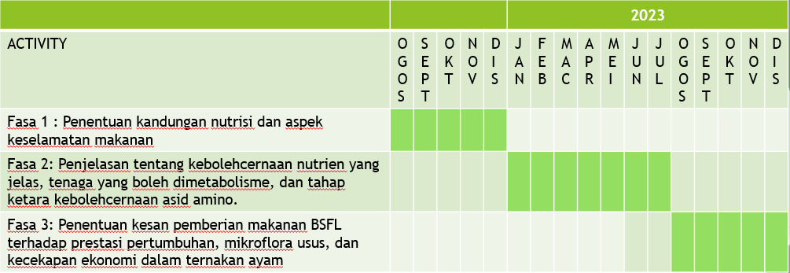
RESEARCH TIMELINE
5%
30%
65%

