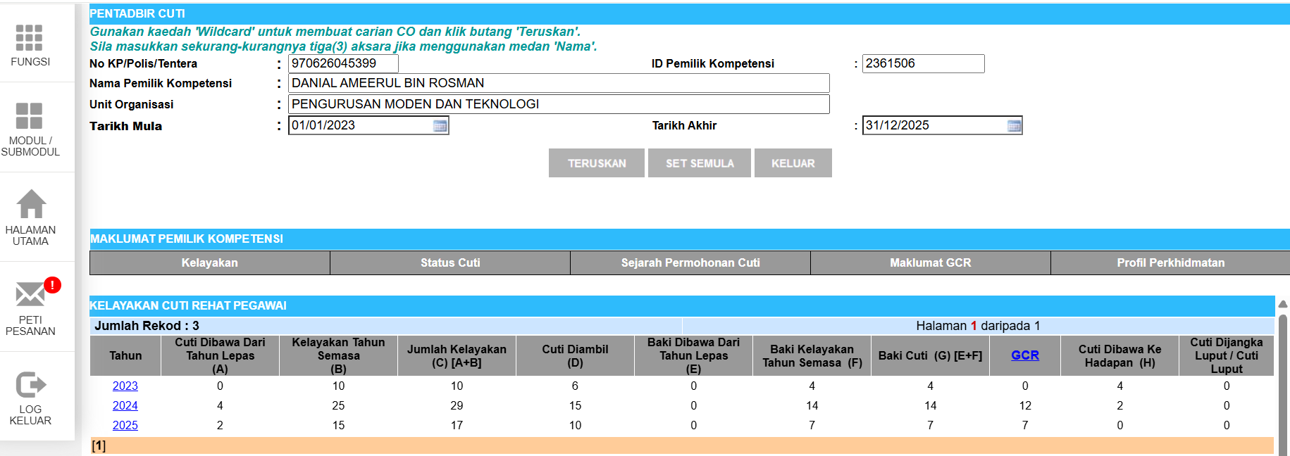
- DANIAL AMEERUL BIN ROSMAN
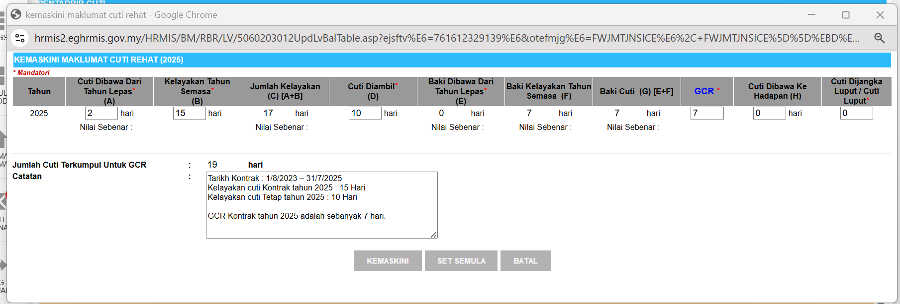

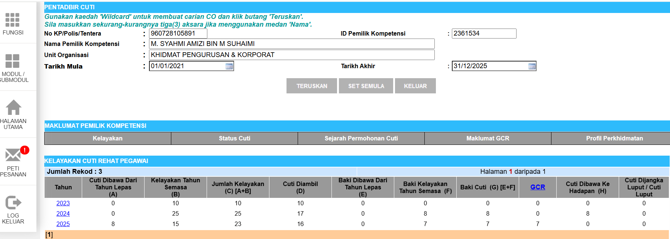
- M. SYAHMI AMIZI BIN M SUHAIMI
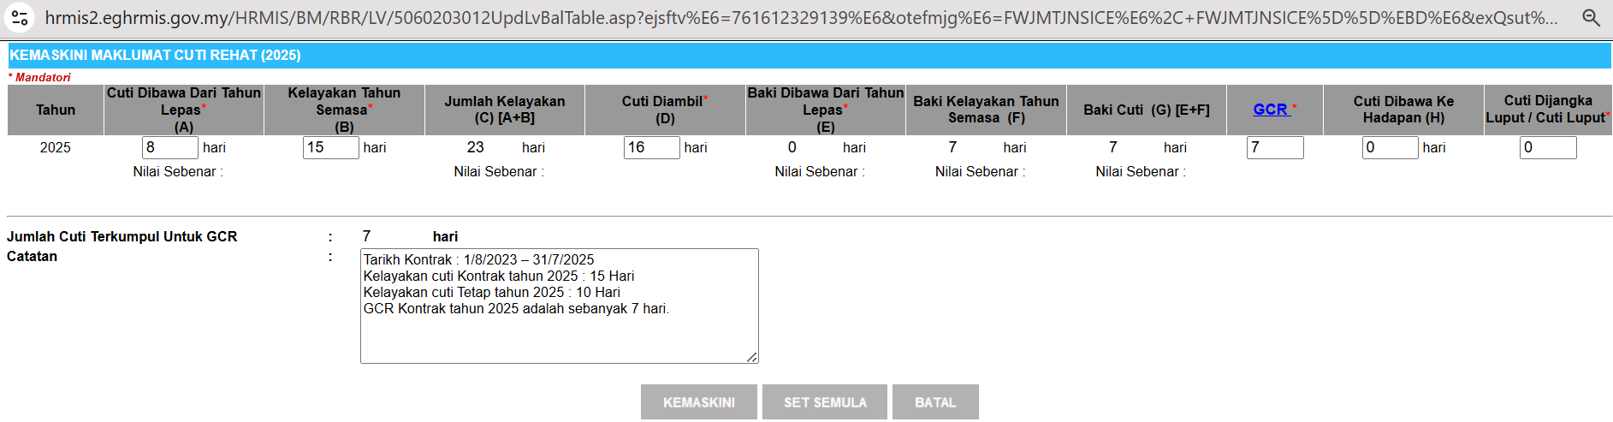

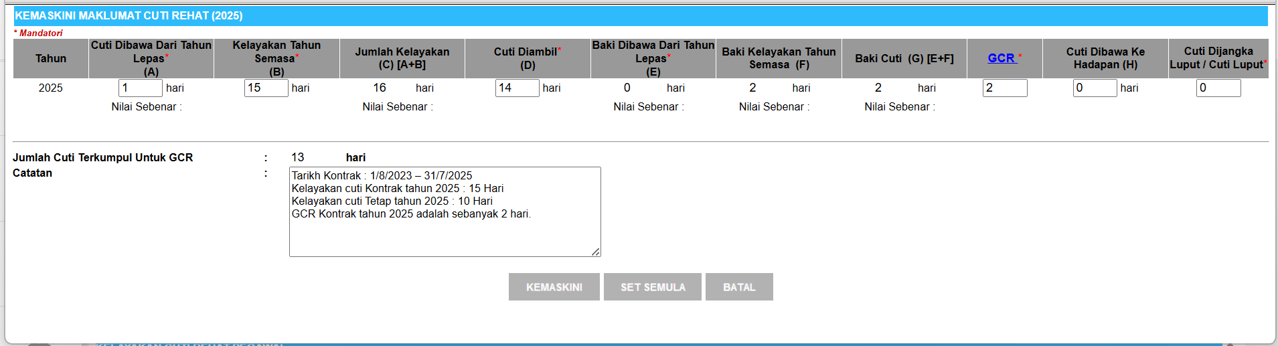
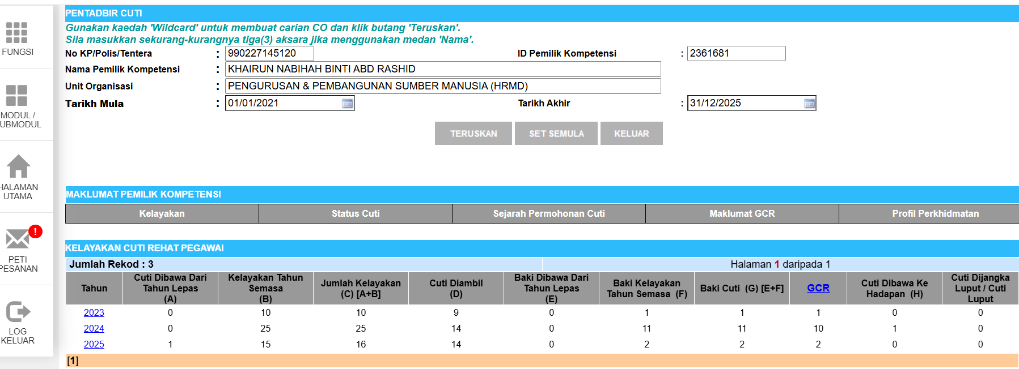
- KHAIRUN NABIHAH BINTI ABD RASHID

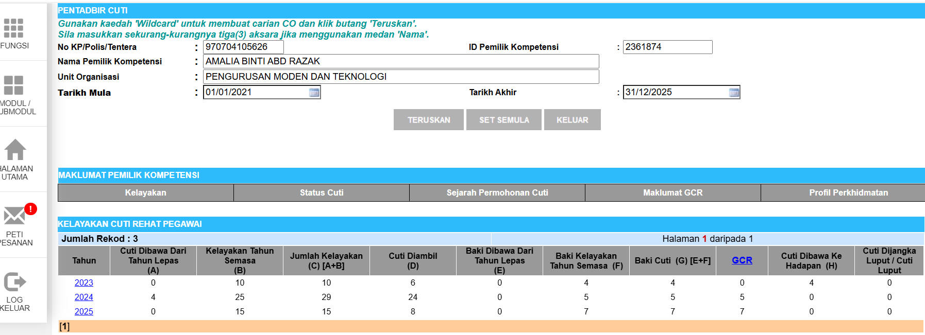
- AMALIA BINTI ABD RAZAK
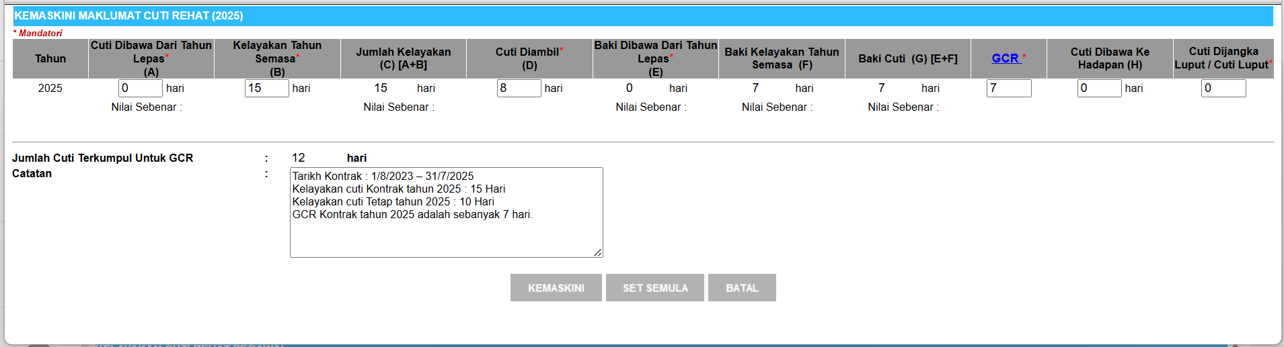

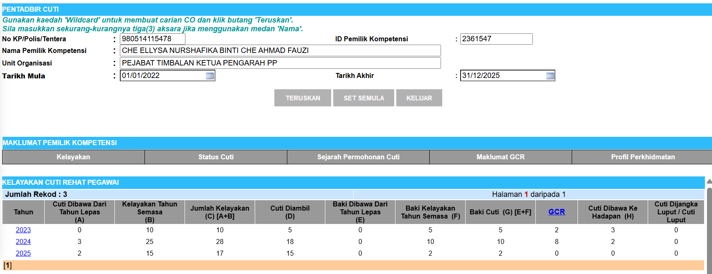
- CHE ELLYSA NURSHAFIKA BINTI CHE AHMAD FAUZI
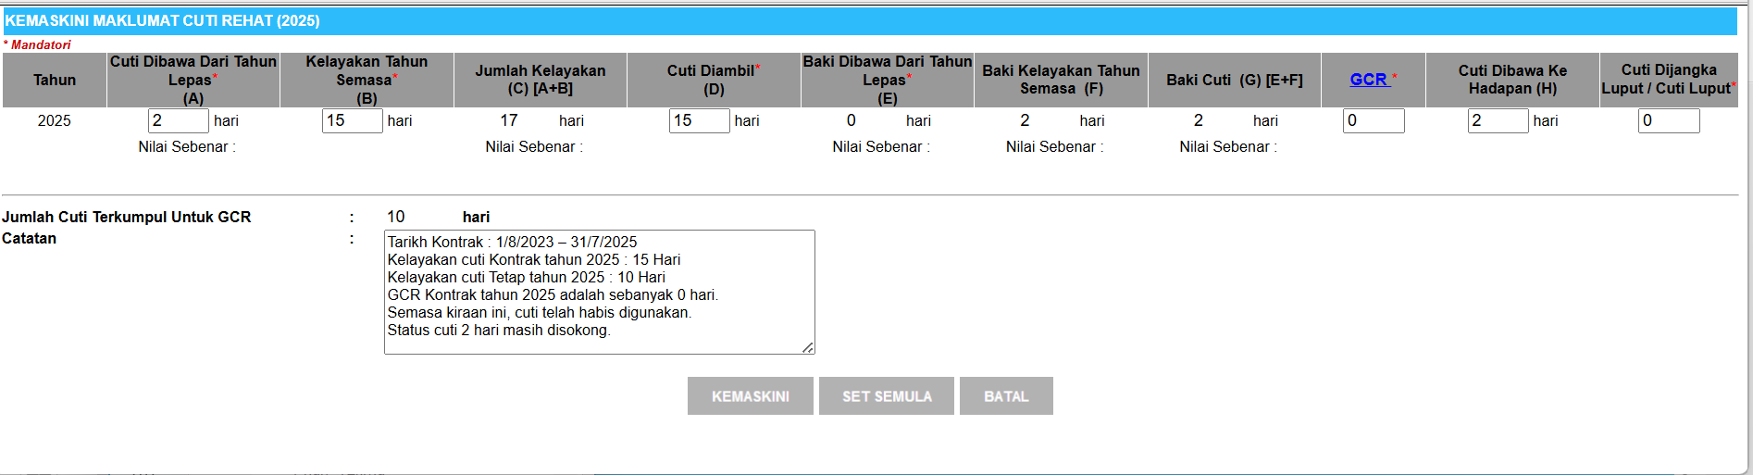

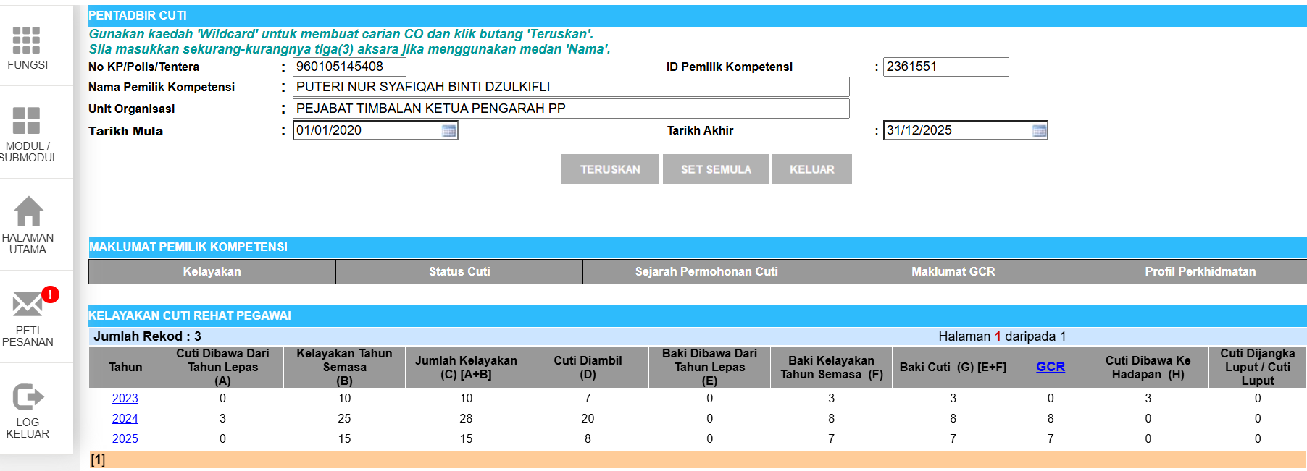
- PUTERI NUR SYAFIQAH BINTI DZULKIFLI
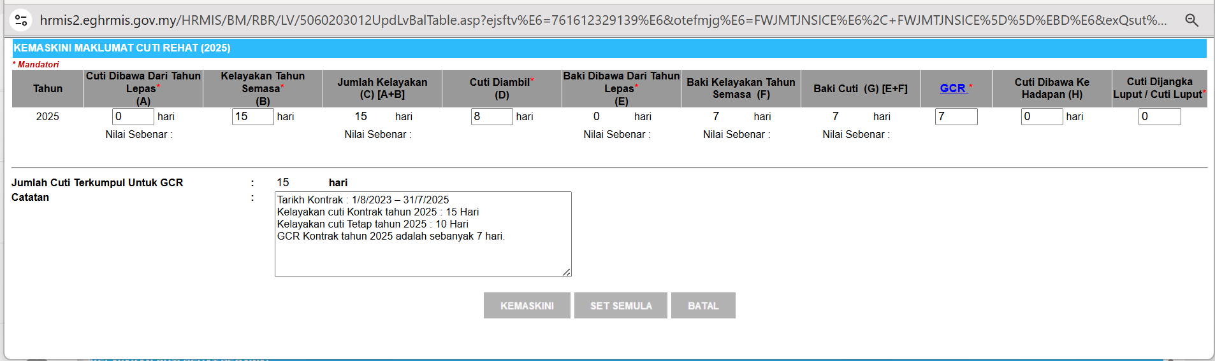

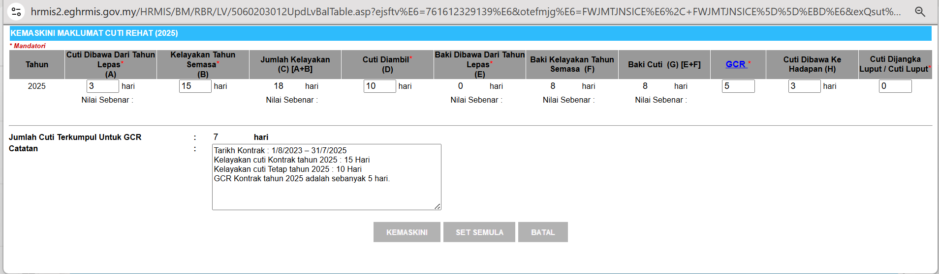
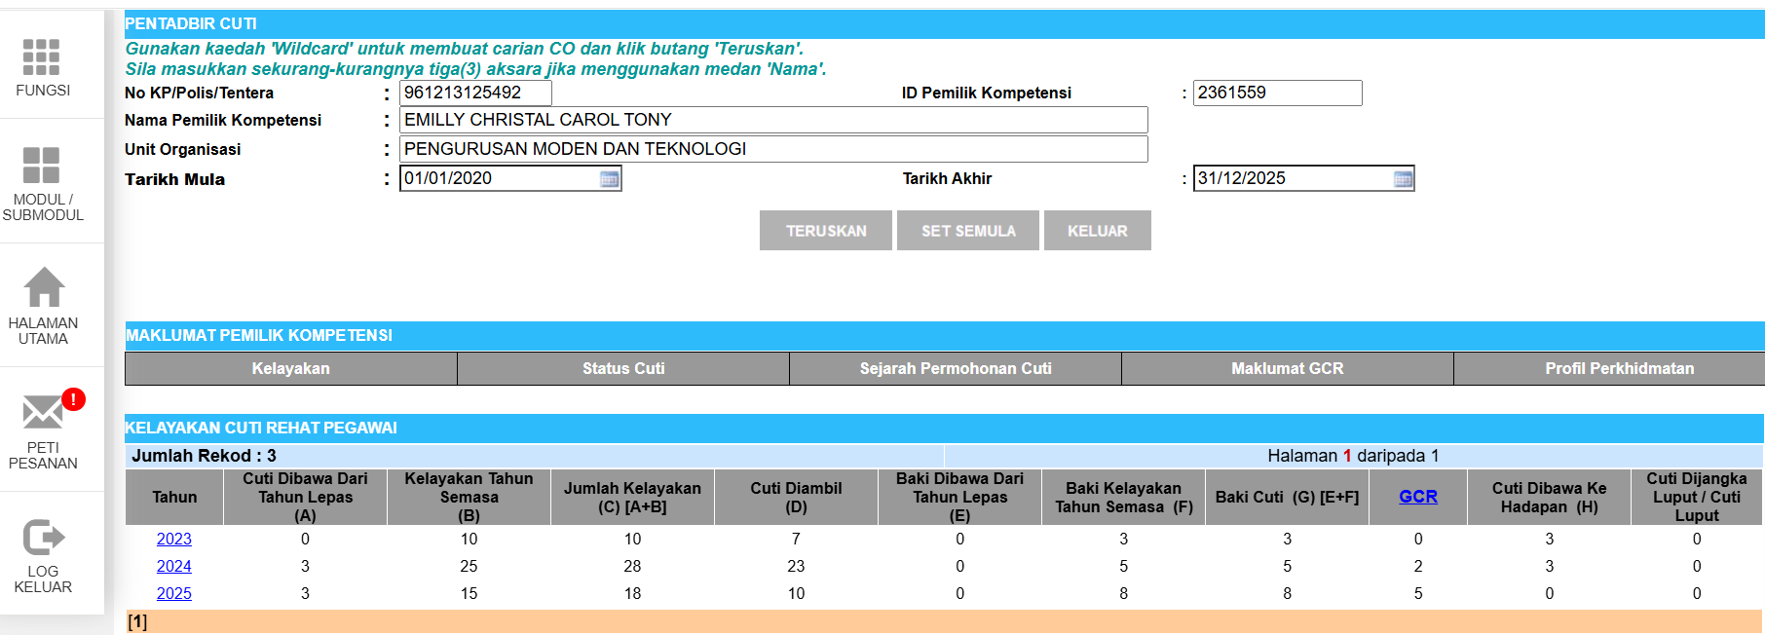
- EMILLY CHRISTAL CAROL TONY

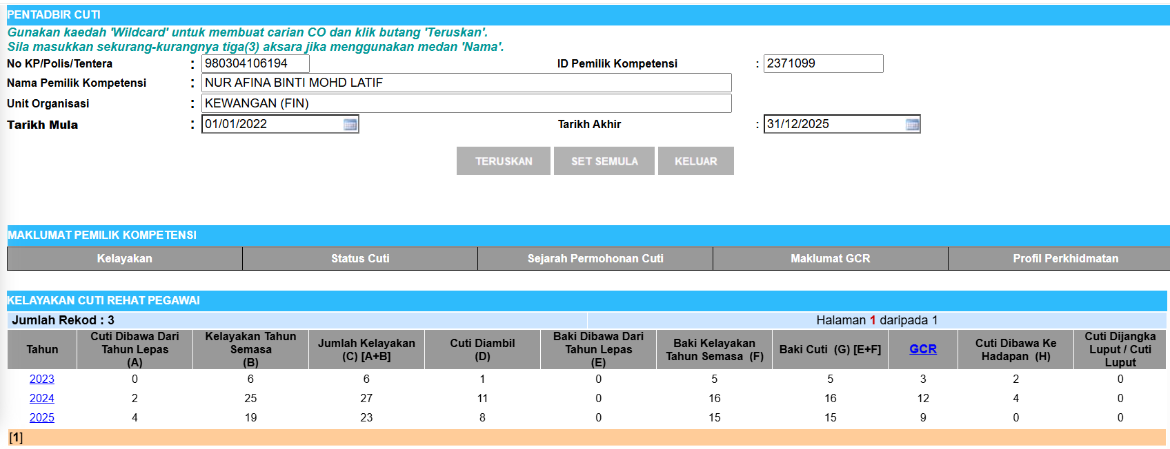
- EMILLY CHRISTAL CAROL TONY
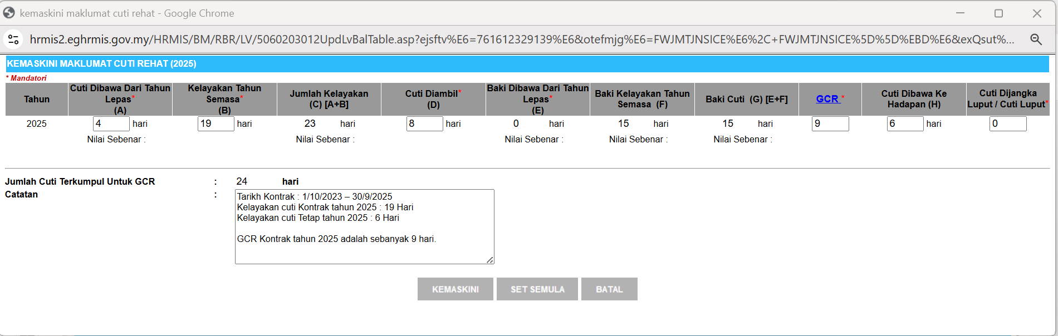
s

