COST
Service | Rate (RM) | Requirement | Total (RM) | Balance / New
FORE
Industrial Expert  (P29105) | 400.00 per hour | 70 hours x 3 experts | 84,000.00 | 81,600.00
Report Writer  (P29112) | 200.00 per page | 25 80 pages x 1 report | 5,000.00 | 16,000.00
Facilitator  (P29105) | 1,800.00 per day | 5 workshops x 2 days | 27,000.00 | 19,800.00
Resident package  (P29402) (P29407) | 400.00 per pax per day | 1 5 workshops x 2 days x 30 pax | 120,000.00 | 24,000.00
Full day Seminar Package  (P29401) | 180.00 per pax per day | 1 workshop x 2 days x 30 pax | 27,000.00 | 21,600.00
 |  | TOTAL | 260,000.00 | 163,000.00
OPERATIONAL
Claims (mileage, meals, taxi/grab etc) (P21102) | 2,000.00 per officer | 2 officers | 4,000.00 | 1,000.00
Flight return (P21101) | 1,000.00 per officer per session | 2 officers x 2 sessions | 4,000.00 | 2,000.00
 |  | TOTAL | 8,000.00 | 3,000.00
TOTAL (RM) |  |  | 268,000.00 | 168,000.00

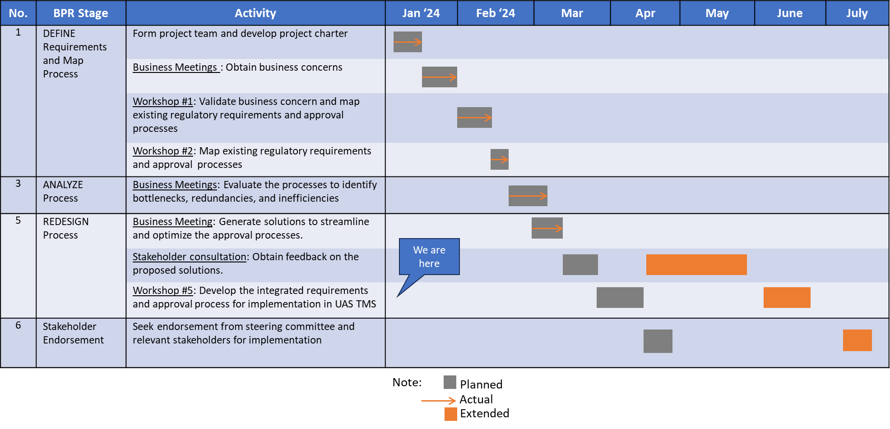
MILESTONE CHART

