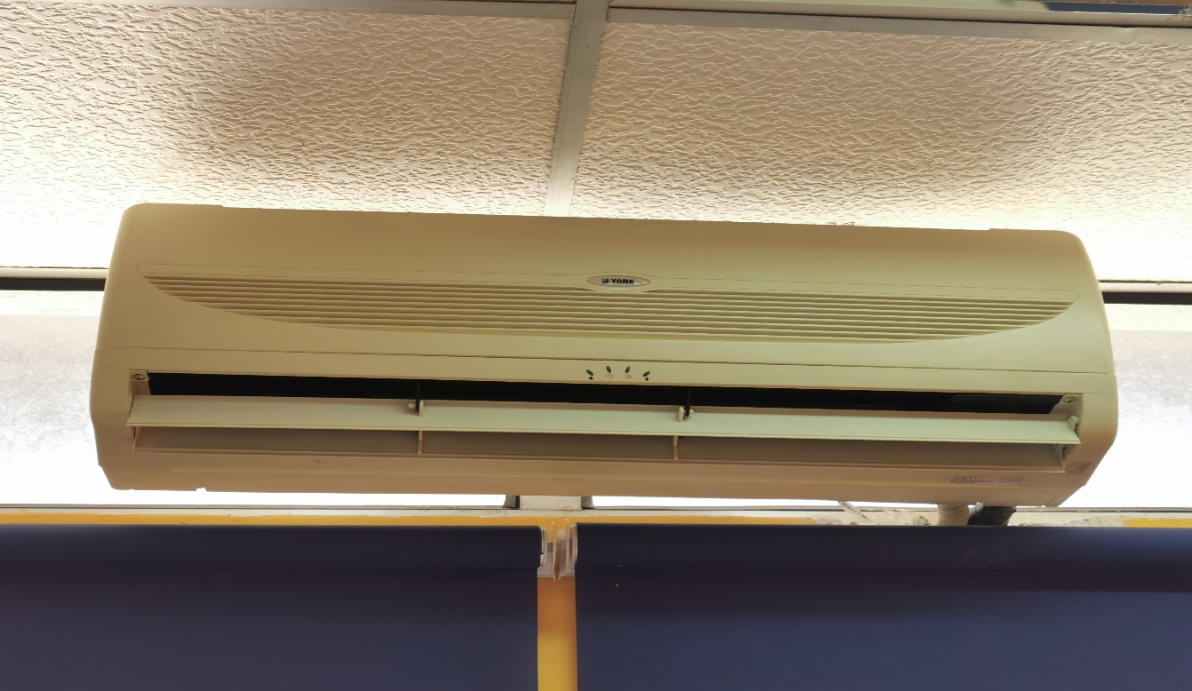
Gambar Penghawa Dingin Rosak
Bilik Pegawai 1

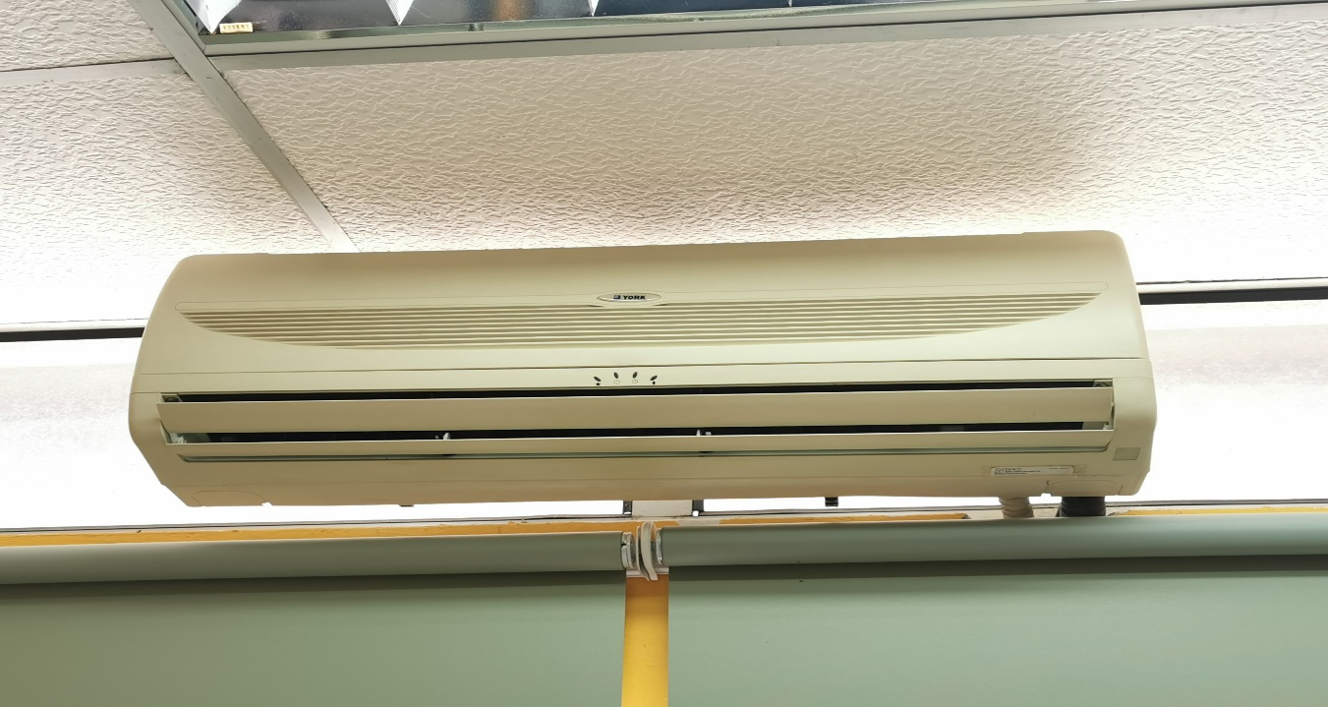
Bilik Pegawai 2

Gambar Penghawa Dingin Rosak
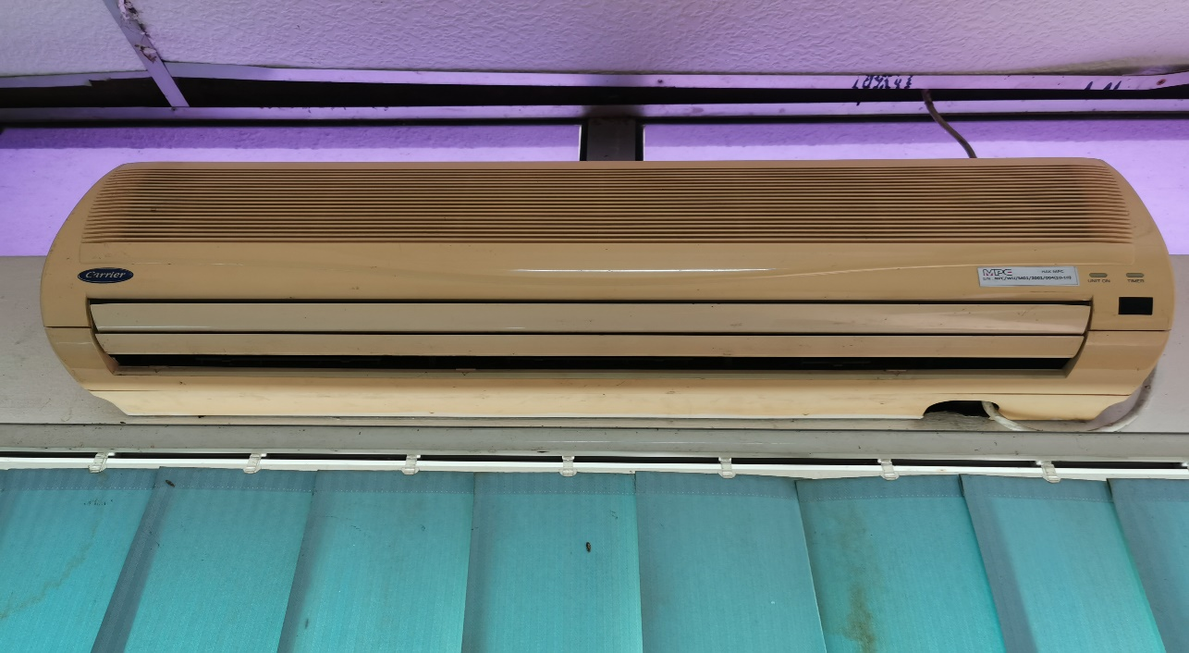
Bilik MSC

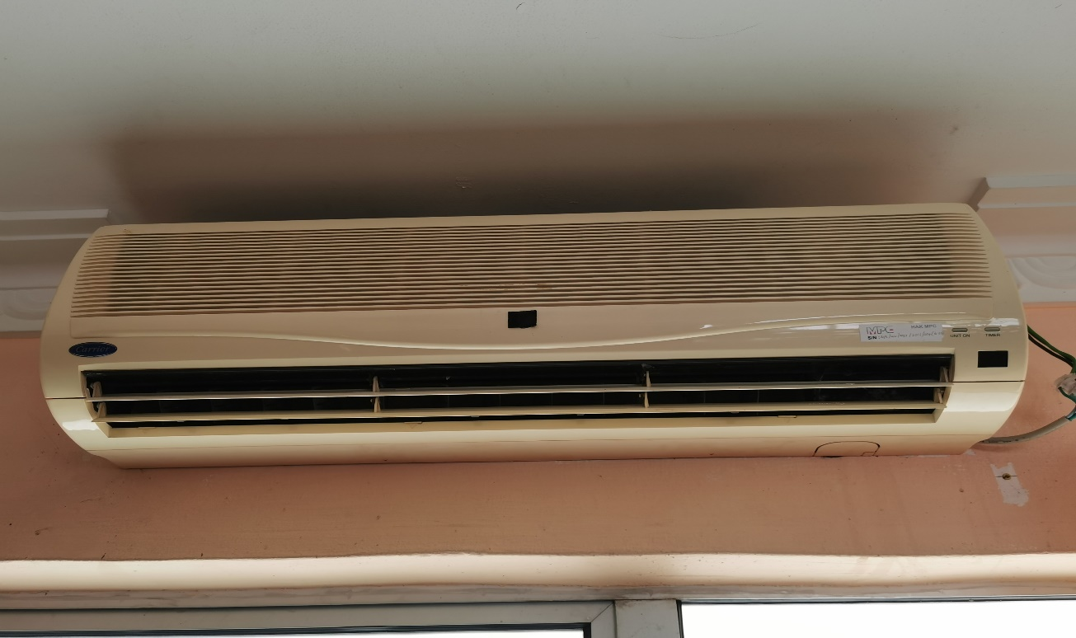
Bilik Six Sigma

Gambar Penghawa Dingin Rosak

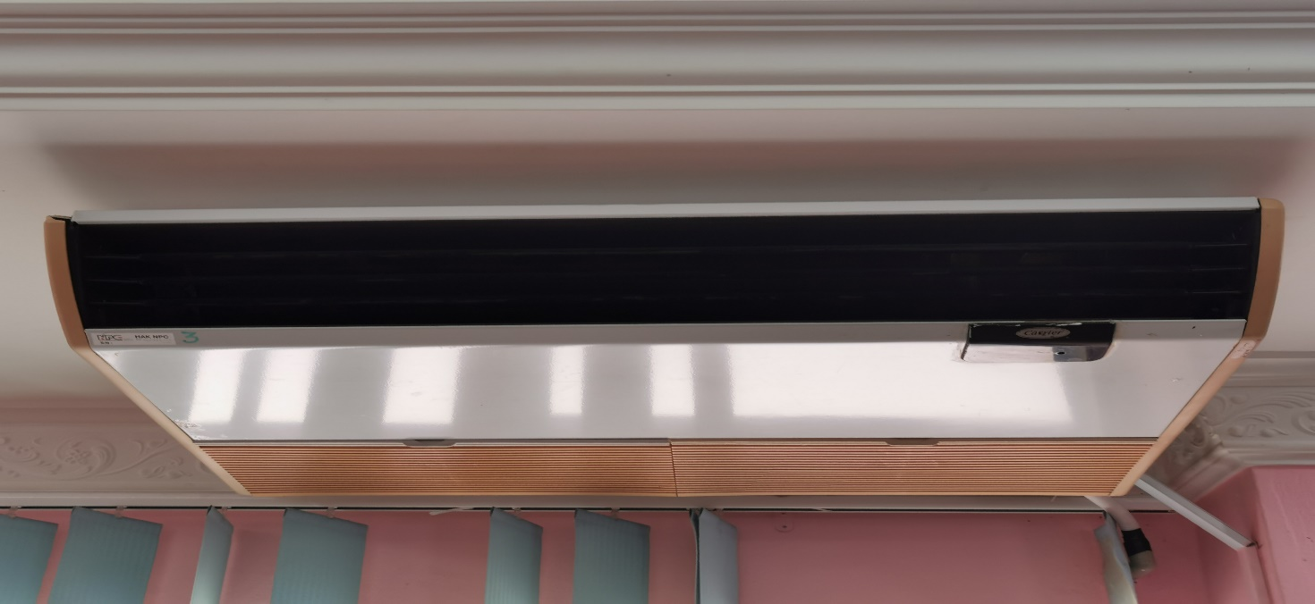
Team Excellence 1

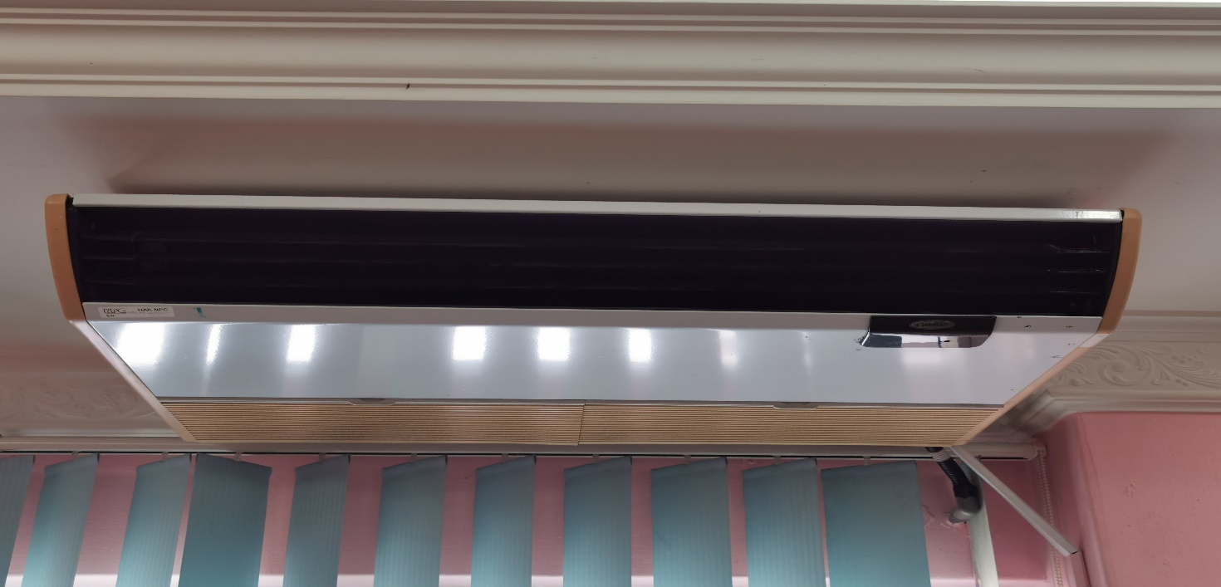
Team Excellence 2

Gambar Penghawa Dingin Rosak

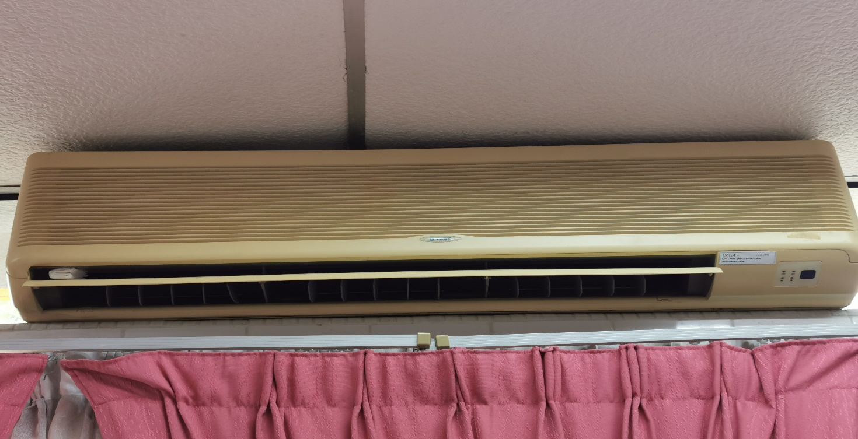
Cafetaria 1

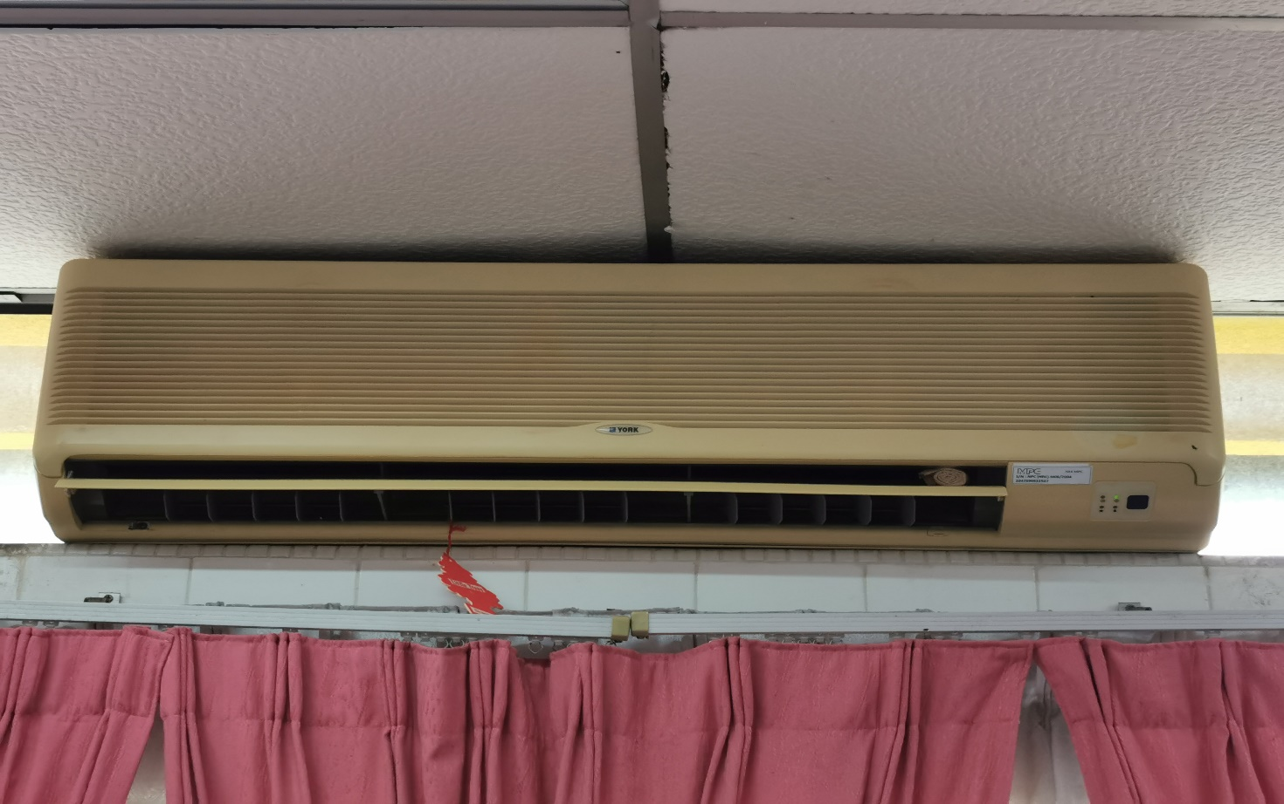
Cafetaria 2
Gambar ‘Portable Amplifier’ Speakar Rosak

